FRAMEWORK
Standard Operating Procedure – Bay Composting
[your facility] Organics Processing Facility

Date of last revision: ______________

Acknowledgement

Gratitude is expressed to the Secretariat of the Pacific Regional Environment Programme (SPREP) implemented and European Union funded, Pacific Waste Management (PacWaste Plus) programme for the continued guidance to the 15 participating countries to improve organic management in the region.

Learn more about the PacWaste Plus programme:

wwwpacwasteplus.org
Introduction
Organic material received, such as yard organics, fish by-product, and cardboard are the “inputs” or “ingredients” of the [your facility] Compost Facility. It is the role of the Facility Operator to provide the correct conditions for this material to be processed into consistent and quality nutrient-rich compost – while minimising environmental harm, and minimising risks to employee health and safety. This Standard Operating Procedure (SOP) guides the effective composting process, providing supervisors and staff the background and guidance on activities to operate and run the facility safely, effectively, and efficiently.
There are 10 key “stages” recommended for effective composting:

- Delivery
- Decontaminate & Separate
- Shred / Size Reduce
- Form Batch
- Composting
- Maturation
- Screening
- Storage
- Bagging
- Dispatch
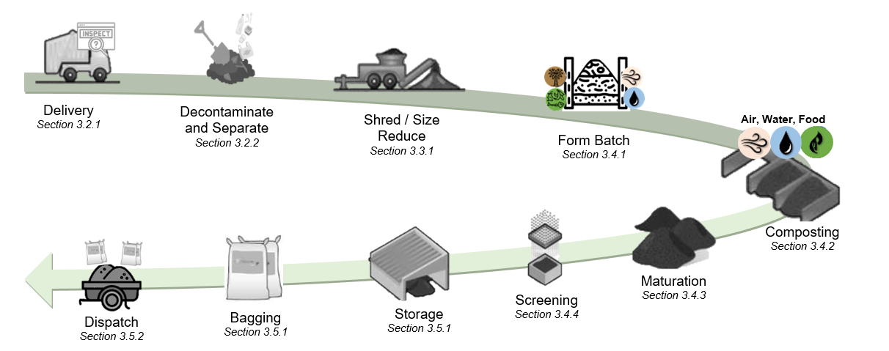
This SOP provides information on recommended tasks to safely and effectively undertake each stage of composting. The SOP is split into three sections:
Part 1 – Quick Guide | Summary information on:  - Overview of the [your facility] Composting Facility operation  - Introduction to the stages of composting and recommended activities for the [your facility] Composting Facility  - Snapshot of daily and weekly tasks for the [your facility] Composting Facility  - Completing daily “Air, Water, Food” Checks on compost Bays and Piles
Part 2 – Stages of Composting | Detailed information on each of the 10 stages of composting, providing guidance on:  - Recommended tasks to be undertaken at each stage  - Particular health, safety, and environment risks at each stage
Part 3 – Appendix / Further Reading | Further information and background reading:  - Introduction to Composting  - Glossary  - Environmental risks and mitigations  - Health & Safety risks and mitigations  - Safe shredder operations  - Facility maintenance  - Logbook template (data collection)

Part 1 – Quick Guide

Quick Guide: Site Overview
Detail | Description
Current as at | Date: ________________________  (When information changes, update the SOP)
Site Operator
Contact
Composting Process | ##-Bay Composting
Staff | List staff working at the facility:
Material Throughput | Expected material throughout - volume and type  Material Cubic Meter/yard / Week  Yard Organics  Food Organics  Fish Organics  Paper / Card  TOTAL
Equipment | List equipment used to operate at the facility:
 | Example:  - Shredder  - 90cm analogue temperature probe  - 10 Litre Buckets (2x)  - Shovels (wide blade) (4x)  - Wheelbarrows (2x) | - Gloves (cut resistant)  - Face Masks (P2)  - Data Record sheets  - Screen  - Machete  - Drag fork / pitchfork
Training | Staff trained  Composting Fundamentals (list staff trained in composting):  Shredder operation and maintenance (list staff trained in shredder operation and maintenance):
Summary Description - Site and Process | The [your facility] Organics Processing Facility composts organic material using a Bay Composting method where organic material is shredded and transferred through ## (provide number of bays) indoor/outdoor (delete one) bays.  Common input material is …………… (supply details – for example: Yard Organics (### cubic meter/yards / week). This material already contains a mix of Carbon (old, rigid, and dry) and Nitrogen (fresh, flexible, and moist) materials).  Other input material includes …………… (supply details – for example: coconut fronds and paper / cardboard (carbon) and food scraps, copra, and fish-by product (nitrogen)).  Medium sized materials (larger that >1 inch thick and/or >4 inch in length) are shredded once received at the facility.  Each new compost “batch” is formed in Bay 1 – by adding organic materials as they are received – ensuing there is a mixture of large and small particle sizes, correct carbon and nitrogen balance, and adding water to ensure material is damp to touch but not too wet.  Bay 1 can hold approximately ## cubic meter/yards of shredded material, formed into a triangular pile with a peak in the centre approximately # m / # ft high. Bay 1 is expected to take ## weeks to fill, upon which the “batch” will be turned into Bay 2 making room for a new batch to be formed in Bay 1.  Batches are to be turned into the next Bay (i.e., batch in Bay ## turned into the Maturation Pile, Bay # to Bay ##, Bay # to Bay #, and so on) in approximate ## week intervals, matching speed in which Bay 1 is filled.  Batches are monitored regularly conducting Daily “Air, Food, and Water” Checks (see Section 1.5).  During the active composting period, the material in Bays 2-## should get to over 130°F and hold this temperature for at least 3 days after each turn to ensure “pasteurisation” (seeds and pathogens are killed).  After approximately ## weeks (dependent on speed in which Bay 1 is filled and turning regimes), the batch from Bay ## will be transferred to the outdoor Maturation Piles where it will undergo final composting process for a further ## weeks (to ensure the batch receives a total of 16 weeks processing) before being screened and bagged for sale.

Quick Guide: Stages of Composting and Key Activities
The following table summarise the recommended activities to be undertaken at each stage of composting at the [your facility] Organics Facility. For further details, see the corresponding section of the SOP.
Stage of Composting | Description | SOP Section
Receive:  Delivery, Inspect, Decontaminate, and Separate  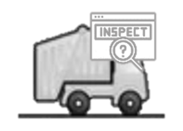 | - Before unloading the delivery truck, visually inspect for contaminants (i.e., plastics, metal, glass, weeds (that have not been pre-approved), pesticides, human sludge / biosolids, and rocks & soil)  - if >25% contaminated, REJECT LOAD: notify owner and direct material to landfill  - if material is clean, unload  - Once material unloaded, use a shovel to separate / spread to further inspect for and remove contaminants:  - plastics, metal, glass – Put in bin for transport to [landfill / dumpsite name] for recycling / disposal  - pesticides and human sludge – Put in bin or wrap in tarpaulin and Transfer to [landfill / dumpsite name] for disposal  - weeds (that have not been pre-approved) – Put in bin or wrap in tarpaulin and Transfer to [landfill / dumpsite name] for disposal  - weeds (that have been pre-approved) – confirm they are not covered in pesticide. If they are, do not accept – Put in bin or wrap in tarpaulin and Transfer to [landfill / dumpsite name] for disposal  - rocks & soil – separate from organic material and stockpile/use onsite  - Separate organic material by size:  - Small materials (<1 inch thick and <4 inch in length – Transfer to forming batch area at Bay 1  - Medium materials (>1 inch thick and/or >4 inch in length) – Transfer to shredding area  - Large / un-shreddable materials (>9 inch thick) – Use for firewood or stockpile / use onsite  - Wet material (fish by-product etc) – transfer to forming batch area at Bay 1 (or place on a tarpaulin or a bed of shredded garden organics and cover with shredded garden organics)  - excess material (that cannot be processed on the day of delivery) can be stockpiled if necessary. Cover with damp cardboard if possible. All materials should be processed within 24 hours of delivery to assist with odour management).  - If weeds are handled, use care to ensure seeds are not spread  - Record data on quantities and types of organics materials received in the logbook (Appendix F) | Section 3.2.1  Section 3.2.2
Processing:  Shred / Size Reduce | - Set up shredder and conduct pre-start and safety checks  - Shred medium-sized material following safe operations (Appendix E), feeding the material through stem end first  - Transfer shredded material to Bay 1 to be formed into a compost batch  - If shredded material cannot be formed into a compost batch on same day, stockpile inside and cover with damp cardboard  - After use, clean shredder with a brush, closely inspecting for weeds and stuck material  - Inspect for damage and complete shutdown activities. Store shredder indoors  - Record data on shedder operation in the logbook (Appendix F) | Section 3.3.1
Composting:  Form Compost Batch  (Bay 1)  1-2 Weeks | - Add new material to Bay 1 to form a compost batch – ensuring correct:  - Food - layer even amounts of “Carbon” and “Nitrogen” material. Note: if the common input material is Yard Organics. This material contains both Carbon and Nitrogen so layering is not necessary.  - Air - ensure a mixture of large and small particle sizes to provide airflow into the batch  - Water - add water so material is damp but not too wet  - Add material daily and form into a triangular piles until the peak is # m / # ft high (approximately ## weeks)  - Complete daily “Air, Water, Food” checks to monitor the performance (see Section 1.5)  - At end of each day, gently form material into a triangular pile and cover with damp cardboard boxes  - The batch is formed (complete) once Bay 1 is full (peak is # m / # ft high)  - Sit batch for minimum of 24 hours (or until new material is shredded and a new batch ready to be started in Bay 1), then turn into Bay 2  - Record data on composition of the batch and results from “Air, Water, Food” checks on the Bay Plaques and logbook (Appendix F) | Section 3.4.1
Composting (Bays 2-##)  6-12 weeks  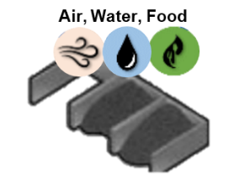 | - Complete daily “Air, Water, Food” checks (see Section 1.5) and complete identified actions  - Turn Bays every ## weeks matching speed in which Bay 1 is filled (i.e., batch in Bay ## turned into the Maturation Pile, Bay ## to Bay ##, and so on)  - Ensure all material in the batch gets fully mixed in the processing (material on the outside of one Bay, to go into the inside of the pile in the next Bay)  - Track the temperature of the batch to ensure materials heats up to over 130°F and holds this temperature for at least 3 days after the first 3-4 turns (heat will kill the weeds and pathogens)  - When watering, ensure material is not overwatered or allow water to run outside the building to reduce soil / water contamination  - After approximately 6-12 weeks, transfer the batch from Bay ## to the outdoor Maturation Piles for final processing  - Track and record composting process and results from “Air, Water, Food” checks on the Bay Plaques and logbook (Appendix F) | Section 3.4.2
Maturation  2-9 weeks 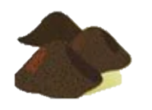 | - Lay cardboard boxes down outside in the Maturation area. Place batch from Bay ## onto cardboard and form into a pile.  - Leave batch to mature for a further ## weeks to ensure the batch receives a total of 16 processing (i.e., if a batch moves through the indoor bays in 7 weeks, it should be stored in the Maturation Piles for approximately 9 weeks, OR if a batch moves through the indoor bays in 14 weeks, it should be stored in the Maturation Piles for approximately 2 weeks)  - Turn Maturation Piles every ## weeks matching speed in which Bay 1 is filled  - Record batch name and date on Data Stake and move the stake with the batch  - Protect the outside Maturation Piles against rain by covering with cardboard or a tarpaulin, especially if heavy rain is forecast  - Complete daily “Air, Water, Food” checks (see Section 1.5)  - When material looks dark and earthy and the temperature remains cool and stable (i.e., air temperature (under 40oC / 100oF)) after turning the compost is mature and ready for screening and use  - Track and record maturation process and results from “Air, Water, Food” checks in the logbook (Appendix F) | Section 3.4.3
Screening | - Screen mature compost through half inch sieve  - Fine material that flows though the sieve is finished compost, ready for bagging and sale  - Larger particles captured by the sieve can be used as mulch or returned back to the active composting process (added to Bay 1) | Section 3.4.4
Storage 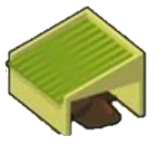 | - Place finished compost in storage piles inside the facility or under a cover  - Storage Piles can be taller and wider than the active composting Bays and Maturation Piles  - Record batch name and date on Data Stake and move the stake with the batch  - If compost is to be stored long-term, turn the Storage Pile every two months to reduce fire risk  - Inspect storage piles weekly, checking for smoke and conduct Air, Water, Food checks  - Temperature should remain cool and stable. If the compost starts getting hot, it indicates it has not finished maturing. Follow actions detailed in the Maturing phase (Section 3.4.3) | Section 3.5.1
Dispatch:  Bag, and Dispatch  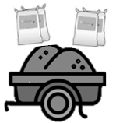 | - If required by customers, place compost into bags for easy handling and transport  - Sell by the bag or trailer load  - Record the batch name and weight / quantity of compost sold/dispatched in the logbook | Section 3.5.1 Section 3.5.2

Quick Guide: Daily Tasks
The following table summarises the recommended daily tasks to be undertaken at the [your facility] Compost Facility.
Image | Actions | SOP Section
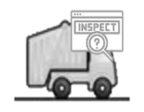 | - Set up receival area, ensuring delivery vehicles can safely access | Section 3.2.1
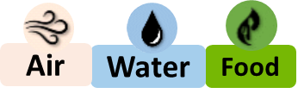 | - Complete daily “Air, Water, Food” checks on all Bays and Maturation Piles – complete identified actions | Section 1.5
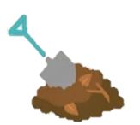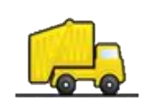 | - Inspect new organic material, decontaminate and separate/sort by size | Section 3.2.1 Section 3.2.2
 | - Set-up shredder and check safety controls  - Safely shred material, and compete logbook | Section 3.3.1
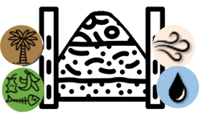 | - Form batch in Bay 1 – add new shredded material, ensuring correct balance of Air, Water, Food | Section 3.4.1
 | - Clean and check tools and machinery | Appendix E
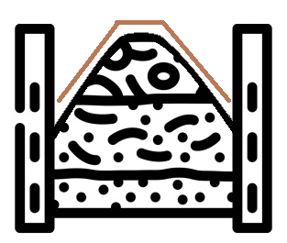 | - Cover Bays and Piles at the end of day with damp cardboard | Section 3.4.2 Section 3.4.3
 | - Sweep and clean the site, paying particular attention to weeds or seeds | Section 3.2.2  Section 3.4.2
 | - Empty bins when full and arrange to be transferred to [landfill / dumpsite name] | Section 3.2.2
 | - Record data on logbook and on plaques / stakes | Section 1.5  Section 3.2.1 Section 3.2.2  Section 3.3.1  Section 3.4.1  Section 3.4.2  Section3.4.3  Section 3.5.2

Quick Guide: Weekly Tasks
The following table summarises the recommended weekly tasks to be undertaken at the [your facility] Compost Facility.
Image | - Actions | SOP Section
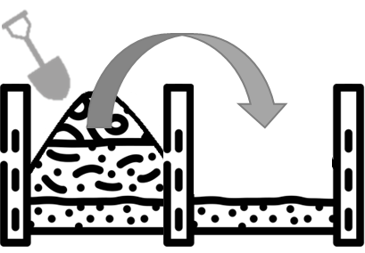 | - Check Bay Plaques and Stakes, identify Bays and Piles needing tuning – complete turning (Bay ## to Maturation Pile, Bay ## to Bay ##, Bay ## to Bay ##, and so forth) | Section 3.4.2 Section 3.4.3
 | - Complete “Air, Water, Food” checks on Storage Areas | Section 1.5
 | - Screen and Bag finished compost (if necessary) | Section 3.4.4
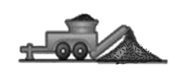 | - Clean tools and machinery, undertake machinery maintenance as needed | Appendix E

Daily “Air, Water, Food” Checks
Complete daily “Air, Water, and Food” on compost bays and maturation piles to monitor the performance of your compost and identify any issues. Keep particular note of presence of smoke or very hot temperatures.
If any issues are identified with the balance of “Air, Water, and Food”, complete the recommended actions as specified.
When completing the smell the check, first smell the whole area carefully as you approach the Bay. If foul odour is detected, do not handle or closely smell materials. If there is no foul odour in the wider area, continue with smell test – i.e., collect a handful of material and smell carefully. Do not closely smell any composting materials without a mask on.
Wear mask, gloves, work boots, and dust resistant eye protection when completing the daily “Air, Water, and Food” checks.
 | Air | Water | Food
 | To assess Air: | To assess Water: | To assess Food
Look:  Check the look of the material… | …if material looks (and feels) dry and crispy, it may indicate the pile has too much air  …if material looks stuck/clumped together or there is not a mix of large and small items, it may indicate not enough air  …if material looks loose and moist and has a mix of large and small items, the airflow is about right | …if material looks dry and rigid it may indicate not enough moisture  …if material looks soggy or have a blueish / greenish tint, it may indicate too much moisture  …if material looks loose and moist, moisture content is about right | …if material looks wet and soggy it may indicate too much nitrogen (due to an excess of nitrates)  …if material looks dry and rigid it may indicate not enough nitrogen  …if material looks loose and moist (and feel damp and smells “good”), the food balance is about right
Feel:  Collect a handful of material from about 10cm deep and squeeze… |  | …if material feels dry and crispy and no water drops are released, it may mean the pile is too dry  …if the material feels wet and soaking, it may mean the pile is too wet  …if a just few drops of water are released the moisture content is about right
Temperature:  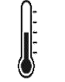  measure with a thermometer, or place a clean machete or shovel into the pile for one minute |  |  | …if pile is <40oC / 100oF) or cool to touch, may indicate too much carbon  … if pile is >65oC / 150oF or too hot to touch, may indicate too much nitrogen  … if pile is ~55oC / 130oF or warm to touch, the food balance is about right
Smell:  smell the area carefully as you approach bay. If no foul odour experienced, collect a handful of material and smell carefully.  Do not smell close to pile/compost without a mask on. | …if material smells like nothing (and feels dry), it may indicate the pile contains too many large items providing too much airflow  …if material smells “bad” (like rotten egg), it may indicate a lack of airflow  …if material smells “good” (like earthy), it likely means the airflow is about right | …if material smells like nothing (and feels dry), it may indicate the pile needs water  …if material smells “bad” (like rotten egg), it may indicate too much moisture  …if material smells “good” (like earthy), it likely means the moisture is about right | …if it smells like nothing (and feels dry), it may indicate too much carbon  …if it smells “bad” (like rotten egg), it may indicate too much nitrogen  … if it smells “good” (like earthy), it likely means the food balance is about right
Actions | To remedy lack of airflow (i.e., if there is a foul odour and/or the compost material is clumped together), turn the pile and add additional items that are “Helpful for Aeration” (i.e., shredded woody materials) | To remedy lack of moisture (i.e., compost is too dry, and feels old, rigid, and dry), add water or additional items that are “Helpful for Water Retention” (i.e., fresh damp material such as fish by-product or grass clipping). Add water slowly and sprinkle over the whole pile.  To remedy too much moisture (i.e., if there is a foul odour and/or it looks soggy and/or there is a blueish / greenish tint), turn the pile and add additional dry items that are “Helpful for Aeration” (i.e., shredded woody materials) | To remedy if too much nitrogen (i.e., there is a foul odour and/or materials look wet and soggy), turn the pile and add additional items that are “High Carbon” (i.e., shredded woody materials, cardboard)  To remedy too much carbon (i.e., if the compost is cool and there is a surplus of old, rigid, and dry materials), turn the pile and add additional items that are “High Nitrogen” (i.e., fish by-product or grass clipping)

Table of Contents

1 Introduction 2
Part 1 – Quick Guide 4
1.1 Quick Guide: Site Overview 4
1.2 Quick Guide: Stages of Composting and Key Activities 6
1.3 Quick Guide: Daily Tasks 10
1.4 Quick Guide: Weekly Tasks 11
1.5 Daily “Air, Water, Food” Checks 12
Table of Contents 15
2 Part 2 – 10 Stages of Composting 17
2.1 Introduction / Purpose of this Standard Operating Procedure 17
2.1.1 How to Use this Standard Operating Procedure 17
3 Composting Stages 19
3.1 Start of Shift 19
3.2 Receiving Materials 20
3.2.1 Delivery 20
3.2.2 Decontaminate and Separate 22
3.3 Processing Phase 25
3.3.1 Shred / Size Reduce 25
3.4 Composting Phase 27
3.4.1 Form Compost Batch 27
3.4.2 Composting 31
3.4.3 Maturation 34
3.4.4 Screening 37
3.5 Dispatch 38
3.5.1 Storage and Bagging 38
3.5.2 Dispatch 40
APPENDIX 42
Appendix A - Introduction to Composting 42
Food: Carbon and Nitrogen 42
Balancing Air, Water, and Food 44
Phases of Composting 45
Useful Resources 46

Appendix B - Glossary 47
Appendix C - Environmental Risks and Mitigations 49
Appendix D - Health & Safety Risks and Mitigations 54
Appendix E - Safe Shredder Operations and Facility Maintenance 57
Appendix F - Logbook Template (Data Collection) 58

Part 2 – 10 Stages of Composting

Introduction / Purpose of this Standard Operating Procedure
Organic material, such as yard organics, fish by-product, and cardboard are the “inputs” or “ingredients” of the [your facility] Compost Facility. It is the role of the Facility Operator to provide the correct conditions for this material to be processed into consistent and quality nutrient-rich compost – while minimising environmental harm, and minimising risks to employee health and safety.
This SOP guides the effective composting process, providing supervisors and staff the background and guidance on activities to operate and run the facility safely, effectively, and efficiently.
    - How to Use this Standard Operating Procedure
There are 10 key “stages” recommended for effective composting (illustrated in Figure 1 and Figure 2):

- Delivery
- Decontaminate and Separate
- Shred / Size Reduce
- Form Batch
- Composting
- Maturation
- Screening
- Storage
- Bagging
- Dispatch
Stages of compost are completed chronologically (in order), with a “batch” of organic material progressing though each stage until it is processed into finished compost ready for dispatch (use/sale). An effective composting process will have many stages of compost being undertaken concurrently (at the same time).
Each stage of composting is featured as a section in Part 2 of the SOP. Information is provided on recommended tasks to be undertaken to complete each stage at the [your facility] Compost Facility, providing details of recommended tasks and actions to be undertaken, and particular health, safety, and environment risks to be aware of.
Figure 1 Key Stages of Composting at the [your facility] Organics Facility

Figure 2 Site Map – [your facility] Facility
Entrance/Exit
Road
Sketch your facility:

Example:
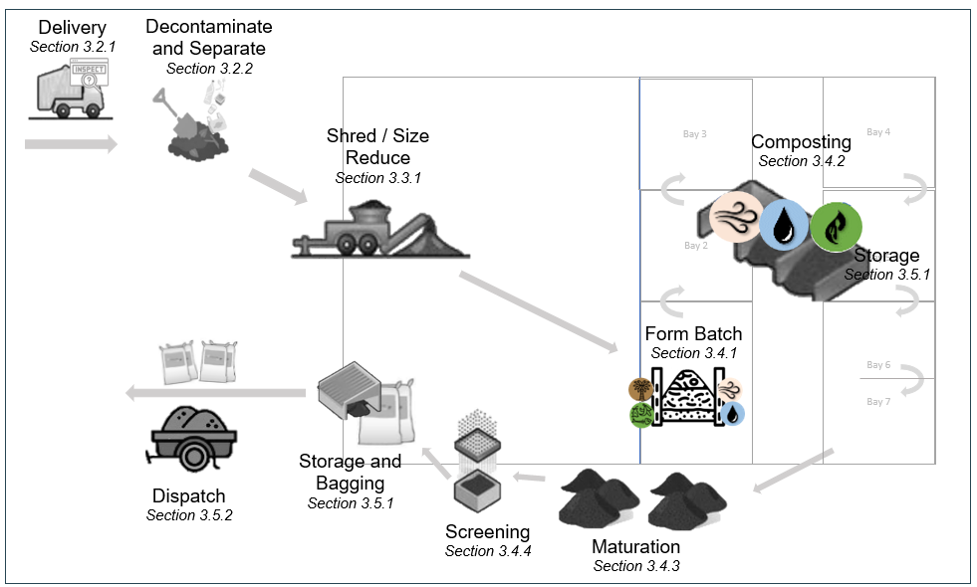

The following organic material types are the common input types and volumes expected at the [your facility] Compost Facility.

Table 1 Common Organic Material Types and Volumes
Organic Material Description | Expected Quantity  m/y³ / Week | Source of Material | Name of Supplier
Yard Organics |  | For example:  Landscapers  Local Government  Household collection
Food Organics
Fish Organics
Paper and Cardboard

Composting Stages

Start of Shift
Recommended actions at the start of the shift include:
Action | Details | Photos
Health & Safety Check | Check all employees fit for work and have the correct PPE – mask, gloves, work boots, and dust resistant eye protection – and tools
Set Up Receival Area | Set up receival area, ensuring delivery vehicles can safely access
Set Up Equipment | Set-up shredder and other equipment  Conduct pre-start check - including checking fuel, oil, etc, and inspecting safety equipment (guards in place, blades clear, safety bar, and break, etc)
Daily “Air, Water, and Food” Inspections | Complete daily Air, Water, and Food checks (see Section 1.5) on all Bays and Maturation Piles – complete identified actions  Record results on the Bay Plaque and logbook (Appendix F)  Keep particular note of presence of smoke or very hot temperatures  When completing smell the check, first smell the whole area carefully as you approach the Bay.  Wear mask, gloves, work boots, and dust resistant eye protection
Turn Piles | Check plaques to identify bays and piles need to be turned (i.e., batch in Bay ## turned into the Maturation Pile, Bay ## to Bay ##, and so on)  When completing transfer, ensure all material in the batch gets fully mixed in the processing (material on the outside of one Bay, to go into the inside of the pile in the next Bay)  Use correct lifting and shovelling technique (bend knees not back, keep stance wide and back straight, bend at the hips). Use assistance (people or tools) if handling large items / loads.

Receiving Materials

Delivery
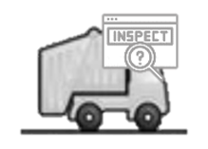
Organic material is delivered to the receival area at the front of the [your facility] Compost Facility. Before unloading, it is visually inspected for contaminants.
Specific actions during the Delivery of Material include:

Action | Details | Photos
Designate Receival Area | Define an area at the front of the site for delivery vehicles to safely access. Allow a safe space for workers to access to inspect the materials. Restrict worker/pedestrian access to remainder of receival area.  Display the Materials Delivery sign  Provide a rubbish bin at the receival area to collect plastics and other contaminants (bin emptied and taken to [landfill / dumpsite name] by next vehicle on return)
Receive Delivery Vehicles | Delivery vehicles access the receival area and await inspection of the load  Keep clear when vehicles are moving
Visually Inspect | Before unloading material, visually inspect to ensure the material is suitable  Look for plastics, metal, glass, weeds (that have not been pre-approved), pesticides, human sludge / biosolids, and rocks & soil  Use gloves and P2 mask when inspecting or handling the material
Reject if Contaminated | If load is >25% contaminated and/or it is not practical to remove the contamination (e.g., human sludge or pesticides mixed through), REJECT LOAD  Provide feedback to the driver / owner on why load is rejected  Divert driver to take material to the [landfill / dumpsite name] for disposal  Use care if weeds are detected to ensure seeds are contained and not spread on the site
Accept if Clean | If material is clean, accept the delivery and tip the load onto the sorting area
Record Data (Logbook) | Record in the logbook:  - Estimated volume (m/y3) of organic material accepted  - Delivery driver and where material received from (i.e., households, landscape company, growers)

Specific Health, Safety, and Environment Risks during the Delivery of Material include the following. Mitigation measures are detailed in the Actions Table above (in orange and green text). Further information is contained in Appendix C and D.
Injury From Heavy Vehicle Operation | Exposure to Pathogens | Exposure to Foreign Objects | Spread of Weeds | Windblown Litter

Decontaminate and Separate
“Contamination” in a compost system can be three different factors:
- Items that will not degrade in the compost system – e.g., plastics, metal, glass
- Items that will inhibit the compost processing or damage the shredder blades – e.g., rocks, soil, large branches (more than 4 inches in diameter), tree stumps, trunks, and excessively stringy vegetation (that will wrap around the shredder feed system and/or knives).
- Items that make the compost unsafe to humans – e.g., pesticides, human sludge

As much contamination as possible are recommended to be removed in the early stages of the compost process, before they get shredded and damage the shredder, or become small pieces spread through the material.
Once received at the [your facility] Facility, organic materials is further inspected, decontaminated, and separated by size to be ready for processing.

Specific actions during the Decontamination and Separation of Materials include:
Actions | Details | Photos
Spread at designated sorting area | Spread material onto a sorting area for inspection. Use a shovel to separate / spread as needed.  Spread any wet material (fish by-product, manure, or food) on a tarpaulin or a bed of shredded garden organics. Note: if this material appears to be contaminant free, do not spread take straight to be formed into batch in Bay 1.  Wear P2 mask, gloves, work boots, and dust resistant eye protection when inspecting or handling the material
Inspect and Remove Contaminants | Wear PPE: P2 mask, gloves, work boots, dust resistant eye protection  Check for contaminants (plastics, rocks, soil, weeds, etc) in the material. If contaminants are found:  - Plastic, Metal, Glass - Put in bin for transport to [landfill / dumpsite name] for disposal or recycling  - pesticides and human sludge - Put in bin or wrap in tarpaulin for transport to [landfill / dumpsite name] for disposal  - Weeds (if un-approved) - Put in bin or wrap in tarpaulin for transport to [landfill / dumpsite name] for disposal (care taken to ensure seeds not spread)  - Rocks & soil - stockpile for use on site (reused for paths, road, gardens)  - Oversized / Un-shreddable woody material - stockpile for firewood or stockpile / use onsite  Wash hands after handling new materials  If dangerous items found (i.e., broken glass, needles, faeces, toxic chemicals), stop work immediately and notify supervisor and team. Safely collect items and divert to landfill using appropriate PPE and careful handling technique.
Separate Materials by Size | Separate organic materials by size and transfer to appropriate area:  - Small materials such as grass, leaves, and small twigs (<10mm thick and/or <100mm) – transfer to forming batch area at Bay 1  - Medium materials (>10mm thick and/or >100mm) – transfer to the shredding area  - Large materials (branches etc too big for shredding) – stockpile until degraded and able to be reduced in size, or use for firewood or other purpose  - Wet material (fish by-product etc) – transfer to forming batch area at Bay 1 (or place on a tarpaulin or a bed of shredded garden organics cover with shredded garden organics). Wet material to never be placed on bare ground due to potential for soil / water contamination.  If handling large items, use correct lifting and shovelling technique (bend knees not back, keep stance wide and back straight, bend at the hips). Use assistance (people or tools) if handling large items / loads  If weeds are handled, use care to ensure seeds are not spread around the site
Stockpile if Necessary | Stockpile excess material if necessary (i.e., that cannot be processed on the day of delivery)  Cover with damp cardboard  Small and wet material should be formed into a batch in Bay 1 within 24 hours of delivery to assist with odour management
Clean-Up | Clear and clean the receiving areas between each load to allow for the next load to be delivered, and to avoid odour and unsightliness, and contaminated water runoff  Clean equipment after use, paying particular attention to any weeds or seeds  Bin collecting plastic, weeds etc to be emptied when full and taken to [landfill / dumpsite name] by next vehicle
Record Data (Logbook) | Record in the logbook:  - quantity and type of organic material received for processing (e.g., 5 m/y3 yard, 0.5 m/y3 fish)

Specific Health, Safety, and Environment Risks during the Decontamination and Separation of Materials include the following.
Mitigation measures are detailed in the Actions Table above (in orange and green text). Further information is contained in Appendix C and D.

Exposure to Pathogens | Exposure to Foreign Objects in Material | Injury from Physical Work | Sun/Heat Exposure | Injury from Heavy Vehicle Operation
Spread of Weeds | Windblown Litter | Soil / Water Pollution | Odour (Air) Pollution | Spread of Disease

Processing Phase

Shred / Size Reduce
Once medium-sized material (>10mm thick and/or >100mm) are clean from contaminants it is ready for size reduction / shredding.
Materials can be shredded daily, or stored until there is enough material to justify setting up and running the shredder.
Specific Actions During Shredding / Size Reducing of Material:
Actions | Details | Photos
Set-Up Equipment / Conduct Pre-start Check | Set up shredder where processed material can be piled near the batch forming area at Bay 1 (to reduce manual handling)  Conduct pre-start check - including checking fuel, oil, etc, and inspecting safety equipment (guards in place, blades clear, safety bar, and break, etc)
Size Reduce – using shredder | Shred material by trained operators following safe operations (Appendix E)  Feed the material through stem end first  Understand the limitations of the shredder and do not attempt to shred items that will damage the shredder or be unsafe  Wear P2 mask, gloves, work boots, dust resistant eye protection  Remove and dispose any contaminants (plastics, metal, stones, etc)
Size Reduce – shredder not available | If the shredder is not available (out for maintenance etc), options to size reduce material include:  - cut or saw into pieces >4 inch length and diameter (less than the size of a loaf of bread)  - stockpile until slightly degraded and undertake size reduction once easier to cut  (or use for firewood - sold or given away)  Use correct cutting technique  Wear mask, gloves, work boots, and dust resistant eye protection
Transfer | Once material is shredded, move to Bay 1 to be formed into a batch (Section 3.4.1).  When moving material, use a wheelbarrow if possible, and correct lifting and shovelling technique (bend knees not back, keep stance wide and back straight, bend at the hips).
Stockpile Material (if necessary) | If material cannot be formed into a batch in Bay 1 on the day of shredding, or if there is an excess of a “high carbon” material (e.g., dried palm frond), the material may be stockpiled:  - Store in a space onsite (ideally inside in a covered / dry area) out of the way from daily processing  - Cover the materials with damp cardboard (to help materials retain their microbes)  - Record date and ensure material is not stored for longer than 4 weeks  Small and wet material should be formed into a batch in Bay 1 within 24 hours of delivery to assist with odour management
Clean, Inspect, and Store Equipment | After use, clean out any residue materials with a brush, taking care to inspect for any weeds  Inspect shredder for damage or bits of material and complete shutdown activities  Store shredder in a covered space
Complete Logbook | Fill in logbook for shredder use (Appendix F), tracking hours of operation and recording management notes/issues

Specific Health, Safety, and Environment Risks during the Shredding and Size Reduction of materials include the following. Mitigation measures are detailed in the Actions Table above (in orange and green text). Further information is contained in Appendix C and D.
Injury from Shredder Operation  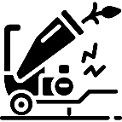 | Exposure to Foreign Objects |  | Injury from Physical Work |  | Sun/Heat Exposure
Spread of Weeds |  | Windblown Litter |  | Odour (Air) Pollution

Composting Phase

Form Compost Batch
Organic material is formed into a compost "Batch” in Bay 1.

Specific actions when Forming a Compost Batch include:
Actions | Details | Photos
Build Batch in Bay 1, adding material daily | As they are received, add organic material to form a batch in Bay 1, providing for Food, Air, and Water:
- Adding “Food” with a 50/50 carbon and nitrogen balance | Food – provide the correct C:N ratio:  Review and understand the “carbon” (i.e., materials that are old, rigid, and dry) and “nitrogen”( i.e., materials that are fresh, flexible, and moist) content of input materials  If the common input material at your facility is Yard Organics. This material already contains a mix of Carbon and Nitrogen materials.  When processing only Yard Organics  - Place shredded Yard Organic material to Bay 1, adding new material daily as received  - At end of day, inspect to ensure there are no clumps and gently form into a triangular shape with a peak in the middle and cover with damp cardboard boxes  - Continue to add material to the batch daily until the peak of the pile is about # m / # ft high  When processing other Carbon or Nitrogen ingredients  - Layer an even quantity of carbon material with the same quantity of nitrogen material:  - Place a layer (4 – 6 buckets, about a foot thick) of “carbon” material on the base of Bay 1  - Layer an even amount (4 – 6 buckets) of “nitrogen” material on top of the carbon material, leaving a space of uncovered carbon material around the sides  - Cover the “nitrogen” material with another layer of “carbon” material  - repeat layering daily as material is received  - At end of day, ensure carbon is the final layer (to reduce odour) and gently form into a triangular shape and cover with damp cardboard boxes  - Continue to layer daily until the peak of the pile is about # m / # ft high
If Adding Cardboard (carbon material):
- Shred dry cardboard into small pieces (less than a half an inch).
- Add cardboard as a “carbon” material at no more than 10% of the overall batch
- Balance cardboard with “nitrogen” materials (such as fish organics)
- Be aware wet cardboard can clump (restricting air and water). Keep close inspection and separate clumps if they form.
Remove and dispose any contaminants (plastics, metal, stones, etc)
Small and wet material should be formed into a batch in Bay 1 within 24 hours of delivery to assist with odour management
Use correct lifting and shovelling technique (bend knees not back, keep stance wide and back straight, bend at the hips). Use assistance (people or tools) if handling large items / loads.
Wear mask, gloves, work boots, and dust resistant eye protection
- Ensuring “Air”, providing airflow for the microbes to breath | Air – provide appropriate airflow:  Ensure the batch contains a mix of large and small particles (large pieces enabling air to flow)  Ensure material is not clumped together. If clumps form, gently separate  Gently form batch into a triangular pile at the end of the day with a peak in the centre, helping air flow into the pile
- Adding “Water”, providing moisture for the microbes | Water – provide the correct amount of moisture:  Add water to the batch as new material is added using sprinklers, hose, watering can, or buckets  Add the water slowly - it may take time for it to soak in. Material in the batch should be damp but not too wet.  When adding water, ensure material is not overwatered or water does not run outside the building to reduce soil / water contamination  Leave the batch overnight then undertake a daily squeeze test (see Section 1.5). Complete identified action.  Cover batch with damp cardboard boxes overnight to keep moisture in
Daily Checks | Conduct daily Air, Water, Food checks (see Section 1.5) on the batch as it is being formed  Complete identified actions  When completing smell the check, first smell the whole area carefully as you approach the Bay. If a foul odour is detected, do not handle or closely smell materials. If there is no foul odour in the wider area, continue with smell test – i.e., collect a handful of material and smell carefully. Do not closely smell any composting materials without a mask on.  Wear mask, gloves, work boots, and dust resistant eye protection
Batch Formed | Once the peak of the pile in Bay 1 is about # m / # ft high, the batch is formed  Cover with damp cardboard and leave for a minimum of 24 hours (or preferably longer until new material is ready to be formed and a new batch can be started), to allow the composting process to start  Transfer the batch to Bay 2
Record Data (Plaque and Logbook) | Record data on the Bay Plaques and logbook (Appendix F) to monitor and track the material through the process:  - Batch name / number  - Date batch started  - Input quantity (number of bucket loads) and type  - Daily temperature (help confirm compost process has started)  - Results from daily checks  - Issues identified / actions taken with batch  - Date of next check  - Planned transfer date to bay 2 (in approximately 10 days time)

Specific Health, Safety, and Environment Risks when Forming a Batch include the following. Mitigation measures are detailed in the Actions Table above (in orange and green text). Further information is contained in Appendix C and D.
Exposure to Pathogens | Legionnaires Disease | Injury from Physical Work | Windblown Litter | Water Pollution | Odour (Air) Pollution

Composting
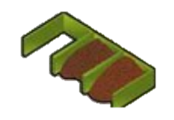
Once a batch is moved to Bay 2 the active composting process will commence.
Specific actions during the Composting phase include:

Actions | Details | Photos
Daily “Air, Water, and Food” Inspections | Complete daily Air, Water, and Food checks (see Section 1.5)  Record results on the Bay Plaque and logbook (Appendix F)  Keep particular note of presence of smoke or very hot temperatures  When completing smell the check, first smell the whole area carefully as you approach the Bay. If a foul odour is detected, do not handle or closely smell materials. If there is no foul odour in the wider area, continue with smell test – i.e., collect a handful of material and smell carefully. Do not closely smell any composting materials without a mask on.  Wear mask, gloves, work boots, and dust resistant eye protection
Undertake Identified Actions | Complete identified actions from the daily Air, Water, and Food checks (see Section 1.5), i.e.,  - If batch identified as too wet, not enough airflow, or contains too much nitrogen material, turn the pile and add additional dry carbon items that are “Helpful for Aeration” (i.e., shredded woody materials)  - If pile identified as too dry or contains too much carbon material, add water or additional nitrogen items that are “Helpful for Water Retention” (i.e., fresh damp material such as fish by-product or grass clipping).  When adding water, ensure material is not overwatered or water does not run outside the building to reduce soil / water contamination
Turn Piles | Turn material between bays every ## weeks, matching speed in which Bay 1 is filled ( i.e., batch in Bay ## turned into the Maturation Pile, Bay 6 to Bay ##, and so on )  To minimise the need for staff to transfer more than two Bays on any given day, pre-empt transfer days by:  - Recording dates on the Bay Plaques and completing transfer per the schedule  - Keeping watch on Bay 1, when it is:  - 3 days from being fill, transfer material from the last bay (Bay ##) to the Maturation Pile (Section 6.3.3) and Bay ## to Bay ##  - 2 days from being fill, transfer material from Bay ## to Bay ## and from Bay ## to Bay ##  - 1 day from being fill, transfer material from Bay 3 to Bay 4 and from Bay 2 to Bay 3  When completing transfer, ensure all material in the batch gets fully mixed in the processing (material on the outside of one Bay, to go into the inside of the pile in the next Bay)  Use correct lifting and shovelling technique (bend knees not back, keep stance wide and back straight, bend at the hips). Use assistance (people or tools) if handling large items / loads.
Clean-up | Clear and sweep the composting area to avoid odour and vermin, and contaminated water runoff
Composting Complete | Active composting period will take approximately 6-12 weeks  Track composting process by measuring temperature - Once the pile no longer heats up after turning, the compost is entering the maturation phase
Record Data (Plaque and Logbook) | Keep records of batch performance by recording data on the Bay Plaque and logbook (Attachment 1). Record:  - Batch name / number  - Date turned into Bay (Bays 2-##)  - Date of Air, Water, and Food checks  - Results from daily checks  - Temperature  - Issues identified / actions taken with batch  - Date of next Air, Water, and Food check  - Planned transfer date to next Bay (in approximately ## days time, matching speed in which Bay 1 is filled)
Analyse Data | Analyse data to understand and track composting performance and process:  - confirm batch is pasteurised by monitoring temperature - the material gets over 130°F and holds temperature for at least 3 days after the first 3-4 turns (heat will kill the seeds and cuttings)  - track phase of composting – when entering the maturation phase, the compost pile will naturally get cooler

Specific Health, Safety, and Environment Risks during the Composting Phase include the following. Mitigation measures are detailed in the Actions Table above (in orange and green text). Further information is contained in Appendix C and D.
Exposure to Pathogens | Legionnaires Disease | Injury from Physical Work | Sun/Heat Exposure
Fire In Composting Material | Soil / Water Pollution | Spread of Disease | Spread of Weeds

Maturation
Once the composting process is complete, the material can be stored in outdoor Maturation Piles to mature for a further 2-9 weeks (to ensure the batch receives a total of 12-16 processing).
Specific actions during the Maturation Phase include:
Actions | Details | Photos
Build Maturation Pile | Lay an approximately 10 x 10ft (3x3m) cardboard square on the ground (to reduce soil contamination)  Move batch from Bay ## onto cardboard and build into triangular pile approximately 8 x 8 x 5ft (2.5 x 2.5 x 1.5m) with peak in the centre  Use correct lifting and shovelling technique (bend knees not back, keep stance wide and back straight, bend at the hips). Use assistance (people or tools) if handling large items / loads.  Wear mask, gloves, work boots, and dust resistant eye protection  Record batch name and date on Data Stake and insert stake in new material to allow tracking of each batch
Complete Daily “Air, Water, and Food” Inspections and Undertake Identified Actions | Undertake daily Air, Water, and Food (see Section 1.5) checks to track performance and identify issues  Keep particular note of presence of smoke or very hot temperatures  Undertake identified actions – i.e., add water if material is too dry, turn if clumping together, etc (Section 1.5)  Track temperature in particular to confirm compost is mature (i.e., material remains cool and stable (i.e., air temperature (under 40oC / 100oF)) after turning)  When completing smell the check, first smell the whole area carefully as you approach the Bay. If a foul odour is detected, do not handle or closely smell materials. If there is no foul odour in the wider area, continue with smell test – i.e., collect a handful of material and smell carefully. Do not closely smell any composting materials without a mask on.
Cover | Cover Maturation Piles with cardboard to protect and contain material and shelter from rain  If heavy rain is forecast, cover with a tarpaulin if possible
Transfer / Turn Maturation Pile | Turn Maturation Piles every ## weeks by moving batch down maturation pile area (Maturation Pile 1 to 2 and so forth) on the same schedule as Bay transfer  Update and move Data Stake with the batch  Use correct lifting and shovelling technique (bend knees not back, keep stance wide and back straight, bend at the hips). Use assistance (people or tools) if handling large items / loads.
Maturation Complete | Compost is mature and ready for screening and use when the material:  - looks dark and earthy  - temperature remains cool and stable (i.e., air temperature (under 40oC / 100oF)) after turning
Record Data (Data Stake and Logbook) | Record the results of daily checks on the Data Stake and in the Log Book, recording:  - Batch name / number  - Date maturation pile started  - Date of Air, Water, and Food check  - Results from daily checks  - Temperature  - Issues identified / actions taken with pile  - Date of next Air, Water, and Food check  - Planned date for Maturation Pile Turn (in approximately 10 days time)
Analyse Data | Analyse data to understand performance of particular batches though composting process  Note particular batch’s inputs (yard organics, fish, etc) against speed and performance (issues identified, maturation, temperature etc)  Use data to help inform future compost batch input "recipes” and processing improvements (additional water etc)

Specific Health, Safety and Environment Risks during the during Maturation Phase include the following. Mitigation measures are detailed in the Actions Table above (in orange and green text). Further information is contained in Appendix C and D.
Exposure to Pathogens | Legionnaires Disease | Injury from Physical Work | Sun/Heat Exposure
Fire in Composting Material | Soil / Water Pollution | Spread of Disease | Spread of Weeds

Screening
At the end of the composting process, small pieces of woody material may still be present. The intended use of the compost will determine whether this material needs to be removed though screening. For example, for seed raising, smaller particle sizes are preferred, and the compost is recommended to be screened. For application on a large garden, course materials in the compost are acceptable and screening may not be necessary.
Specific actions during the Screening phase include:
Actions | Details | Photos
Sieve Mature Compost | Place a metal sieve with 1-2cm holes over bag or area where you want screened compost to be stored (to avoid double handing)  Ensure compost is slightly damp before screening to reduce dust. Add water with care - if compost is too wet, there may be clumps and the screen may block.  Place a small amount of compost on the sieve at a time  Use correct lifting and shovelling technique (bend knees not back, keep stance wide and back straight, bend at the hips). Use assistance (people or tools) if handling large items / loads.  Shake the sieve from side to side to assist the screening process  Fine material that flows though the sieve is finished compost, ready for bagging and sale  Larger particles captured by the sieve can be used as mulch or returned back to the compost process (added to Bay 1)  Contaminants such as plastic and stones collected should be removed and placed in a bin for transfer to the [landfill / dumpsite name]
Cleaning | Clean the sieve as you go to remove any build-up of material  Screening will slow down if sieve gets clogged

Specific Health, Safety, and Environment Risks during the during Screening Phase include the following. Mitigation measures are detailed in the Actions Table above (in orange and green text). Further information is contained in Appendix C and D.
Injury from Physical Work | Sun/Heat Exposure | Exposure to Pathogens | Windblown Litter

Dispatch

Storage and Bagging
Mature compost can be stored after screening until dispatched (sold or used). Finished compost can be stored in piles either inside or outside (and covered with a tarpaulin or cardboard boxes). Storage Piles can be taller and wider than the active composting Bays and Maturation Piles.
Specific actions during the Storage and Bagging phase include:
Actions | Details | Photos
Build Storage Pile | Designate area in building as finished compost storage area OR lay an approximately 10 x 10ft (3x3m) cardboard square on the ground outside, separate from Maturation Piles  Place screened finished compost in Storage Piles. Storage Piles can be taller and wider than the active composting Bays and Maturation Piles.  Record batch name and date on the Data Stake and insert stake in pile of newly sieved material to allow tracking of each batch
Inspect and Complete “Air, Water, and Food” Checks and Undertake Identified Actions | Inspect storage piles weekly, checking for smoke and conduct Air, Water, Food checks  Keep particular note of presence of smoke or very hot temperatures  Undertake identified actions – i.e., add water if material is too dry, turn if clumping together  Temperature should remain cool and stable. If the compost starts getting hot, it indicates it has not finished maturing. Follow actions detailed in the Maturing phase (Section 3.4.3).  When completing smell the check, first smell the whole area carefully as you approach the Bay. If a foul odour is detected, do not handle or closely smell materials. If there is no foul odour in the wider area, continue with smell test – i.e., collect a handful of material and smell carefully. Do not closely smell any composting materials without a mask on.
Cover | Cover outdoor Storage Piles with cardboard to protect and contain material and shelter from rain  If heavy rain is forecast, cover with a tarpaulin if possible
Turn / Mix Storage Pile | If compost is to be stored long-term, turn the Storage Pile every two months to reduce fire risk  Update and move Data Stake with the batch  Use correct lifting and shovelling technique (bend knees not back, keep stance wide and back straight, bend at the hips). Use assistance (people or tools) if handling large items / loads.
Bag | If required by customers, place compost into bags for easy handling and transport  Use correct lifting and shovelling technique
Record Data (Data Stake and Logbook) | Record data to track how long the material has been stored, and to ensure the fire risk is managed.  Record data on the Data Stake and in the Logbook, recording:  - Batch name / number  - Date storage pile started  - Date of Air, Water, and Food check  - Results check  - Temperature  - Issues identified / actions taken with pile  - Date of next Air, Water, and Food check  - Date of estimated Storage Pile Turn (approximately 2 monthly)

Specific Health, Safety, and Environment Risks during the during Storage and Bagging include the following. Mitigation measures are detailed in the Actions Table above (in orange and green text). Further information is contained in Appendix C and D.
Exposure to Pathogens | Legionnaires Disease | Injury from Physical Work | Fire in Material

Dispatch
Load bags or compost onto a vehicle to be transported to [provide details where composts will be sold] for sale to the public.

Specific actions during the Dispatch Phase include:
Actions | Details | Photos
Delivery / Dispatch | Load bags of compost onto a vehicle to take to customers, OR sell by the trailer load  Use correct lifting technique (bend knees not back, keep stance wide and back straight, bend at the hips). Use assistance (people or tools) if handling large items / loads  Keep clear when vehicles are moving
Record Data (Logbook) | Record the batch name and volume of compost sold/dispatched in the logbook  Record:  - Volume sold  - What type of customers (i.e., householders, growers, government, landscape companies etc)  Analyse data to understand who is using the material (to help inform future operations and improvements)

Specific Health, Safety, and Environment Risks at the Dispatch Phase include the following. Mitigation measures are detailed in the Actions Table above (in orange and green text). Further information is contained in Appendix C and D.
Injury from Heavy Vehicle Operation | Injury from Physical Work

APPENDIX

Appendix A - Introduction to Composting
Compost is a nutrient rich product that looks and smells like dark, earthy garden soil. Compost is used to enhance soils, which assists with plant growth, crop yields, and water retention. Composting mimics nature’s method of decomposition, allowing organic material to break down “aerobically”, with oxygen. Creatures too small to see (microbes) process organic materials and convert it to compost. Microbes, like humans and animals, need three elements to live and thrive: Air, Water, and Food. Effective composting occurs when these three elements are operating in a balance.
The function of Air, Water, and Food and how they assist the process of composting are explained in the following figure.

Food: Carbon and Nitrogen
Food is a key part of the balance in a compost pile as this is what the microbes eat, and just like humans they need a balanced diet – with the “carbon” (used as a source of energy) and “nitrogen” (for building cell structure) being the key ingredients. All organic matter includes both carbon and nitrogen; just in different percentages. Microbes need more carbon than nitrogen, coincidentally most materials have a higher carbon percentage. Types of “carbon” and “nitrogen” sources in the Pacific and Timor Leste and their ratios are provided in Figure 3.
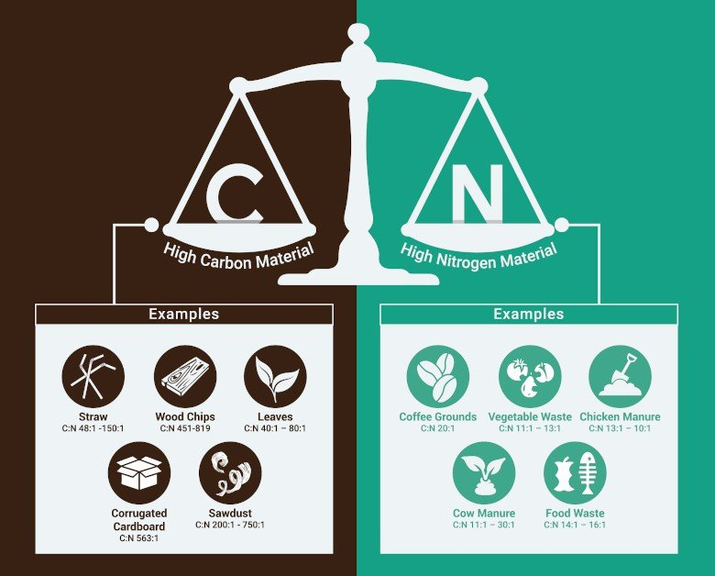
Figure 3 Carbon and Nitrogen Materials Ratios
Palm & Flax
C:N 70:1

Coconut Husks
C:N 100:1
Paper & Card
C:N 500:1

Seaweed
C:N 13.5:1
Sawdust
C:N 300:1
Molasses
C:N 98:1
Fish
C:N 5:1
Food Organics
C:N 9:1

Copra
C:N 11:1
Animal Manure
C:N 12:1
Beer
C:N 12:1
Coffee
C:N 27:1
Carbon Materials =  Old, rigid, and dry | Nitrogen Materials =  Fresh, flexible, and moist

For effective composting, the ideal “Food” or carbon to nitrogen ratio (C:N) of a compost pile is C:N 30:1. The following extract from the PacWastePlus Composting Common Materials Handbook provides guidance on how to calculate this ratio.
Figure 4 Options for Calculating 30:1 C:N
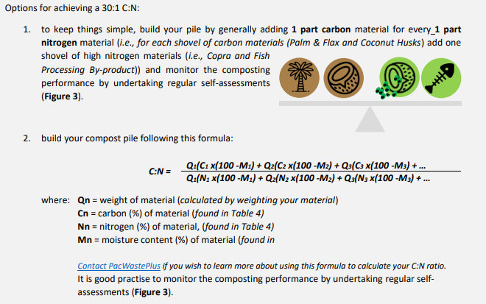

Note:

The common input material at the [your facility] Facility is Yard Organics.

This material already contains a mix of Carbon (old, rigid, and dry) and Nitrogen (fresh, flexible, and moist) materials. Once shredded this can be added to Bay 1 without further blending with other carbon and nitrogen sources.

Balancing Air, Water, and Food
Compost is more than the sum of its parts; it is a living ecosystem. Understanding the materials in the system – and how they balance together to provide the Air, Water, and Food the microbes need – is the foundation for building a healthy compost pile.
Different organic material types have different carbon and nitrogen contents, different particle sizes, and different water retention capabilities. Understanding the behaviour of each material type and their influence on Air, Water, and Food, compost operators can mix materials and develop their own compost “recipes” to turn the organic materials they have into valuable compost.
For example, palm fronds in a compost pile provide high carbon food, and can enhance airflow of a compost pile, but may inhibit water retention. To make effective compost, this material may be layered with items such as by-product from fish processing which is a high nitrogen food, and can enhance water retention, but may inhibit airflow.
More detail on the composting of common materials found in the Pacific can be found in the PacWastePlus document: Composting Common Organic Materials: Handbook for Compost Operators.
Assessment of the Air, Water, and Food and ensuring a correct balance in your compost pile can be completed using a self-assessment. See Section 1.5 for details to complete an assessment on Air, Water, Food.

Phases of Composting
The compost process has three stages - determined by different microbes doing their work. The stages are: Initiation Phase, Thermophilic Phase, and Maturation Phase. Understanding and tracking the stages will allow operators to know where in the process the compost is, and ensure the “pasteurisation” (sanitating and seed killing) phase has occurred.
Figure 5 Phases of Composting
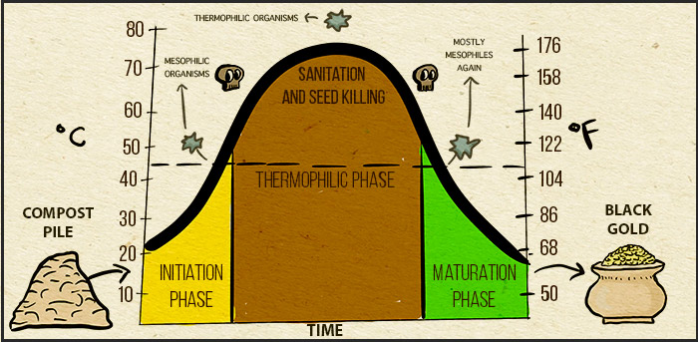
Source: The Science of Compost - Basic to Advanced (untamedscience.com)

Initiation Phase
At the start of a composting process, in Bay 1, there is a lot of “food” and microbes work fast to rapidly break it down. As they do so they produce heat that causes the temperature to rise.
This process takes a few days and is indicated by rapid rise in temperature.
Thermophilic Phase
While microbes have completed the initial break down of material, there is still enough food for them to continue to work. The pile will be warm but not rising rapidly.
The Thermophilic Phase will be occurring in Bays 2 to Bay ## (last bay).
The microbes will be further breaking down the material into finer pieces. The warmth of the pile will provide pasteurisation and enable weeds and pathogens to be killed off. Note: the bay needs to be over 130oF for 3 or more days to provide the pasteurisation to occur.
Warning: If the pile gets too hot the microbes will die, stopping the composting process. The compost requires regular monitoring of Air, Water, and Food and undertaking identified actions such as providing aeration (mixing), and/or water to help control the heat.
Once the microbes have broken down the material (eaten all the available “food”), they slow down and the temperature of the pile decreases. This process can take approximately 12 weeks and can be tracked by measuring the temperature of the compost pile – once the temperature has cooled down the pile has likely reached the end of the Thermophilic Phase.
Maturation Phase
The microbes continue the maturation and curing of the compost to its final stage.
The Maturation Phase will be occurring in Bay ## (last bay) and in the Maturation Piles.
Once it no longer heats up, the compost is finished.

Useful Resources
- Composting Common Organic Materials in the Pacific and Timor-Leste: Handbook for Compost Operators
- Guidelines and Standards for Composting and Compost Quality for Pacific Island Countries and Timor Leste.
- Organics Factsheet: Bay Composting

Appendix B - Glossary
Word | Definition
Aerobic process | Composting process with oxygen or air, as opposed to an anaerobic process (without oxygen)
Air (In relation to checks) | Oxygen provides microbes air to breath. Oxygen makes the composting process work faster and more effectively, and it also reduces likelihood of a compost pile producing bad odour.
Anaerobic process | Composting process in which organic matter is degraded by micro-organisms in the absence of oxygen, as opposed to an aerobic process (with oxygen)
Bacteria | Smallest living organisms and the most numerous in compost; they make up 80-90% of the billions of microorganisms typically found in a gram of compost. Bacteria are responsible for most of the decomposition and heat generation in compost. They are the most nutritionally diverse group of compost organisms, using a broad range of enzymes to chemically break down a variety of organic materials.
Bay composting | Compost facility containing bay of 3 walls that keeps the compost inside
Bioaerosol | Bacteria or fungi in drops of mist in the air
Carbon | Energy-element and is one of the basic building blocks of life. Plants are nearly half carbon. In composting, carbon provides an energy food that sustains the microbes. Materials high in carbon are typically old, rigid, and dry – for example fallen palm fronds and flax/tree litter, dry branches and leaves, and paper / cardboard.
Carbon to Nitrogen (C:N) ratio | The proportion or ratio of the amount of carbon to the amount of nitrogen required in a compost pile. This ratio can be calculated for a mix of different materials to be composted. A C:N ratio of 30:1 is recommended for effective composting.
Air, Water, Food Compost Check | Recommended daily checks on the Air, Water, and Food in a compost pile to understand its performance (see Section 1.5)
Compost | Organic material that has been broken down during composting and now looks and smells like dark, fertile garden soil
Composting | A natural biochemical process in which naturally occurring microorganisms transform raw organic materials into compost products. Although these processes are natural and will happen on their own, compost facility operators are recommended to understand and control the process to provide ideal environmental conditions for bacteria, fungi, and other decomposing organisms.
Composting facility | Facility that accepts compostable material, and processes this into compost through either aerobic or anaerobic processes
Compostable material | Material that was once part of a living thing. Includes: clippings from Yard beautification projects, fallen palm fronds and flax/tree litter, peelings and scraps from food preparation, by-product from food production facilities, manure, and paper / cardboard. Does not include petrochemicals. Has the same definition as organic material.
Contamination | The presence of objects and items that will compromise the compost process. Contamination may include plastics, metal, glass, pesticides, and human sludge.
Decontaminate | To remove the contamination of objects and items that will compromise the compost process.
Fungi | A group of spore-producing organisms feeding on organic matter. Fungi include moulds, yeast, and mushrooms. Fungi are heterotrophs (cannot make their own food) and have a key role in nutrient cycling in an ecosystem.
Food (In relation to checks) | Referring to the organic material that the Microbes eat to create compost. Microbes need the right sort and balance of food to be effective at creating compost, the two key nutrients are “carbon” and “nitrogen”
Food organics | Residues from food, which can be from food preparation, such as fruit and vegetable peelings and trimmings, or leftover, unconsumed food. Spoiled food that is no longer fit for consumption.
Leachate | Liquid that seeps out of a compost pile. Typically produced if the compost has been overwatered.
Maturation Pile | A pile of material that is in the maturing phase of the process.
Microbes | Tiny living organisms including bacteria and fungi which process organic materials into compost. There are billions of microbes typically found in a gram of compost
Mix Material | The action of physically turning organic materials to mix them together.
Nitrogen | Protein-element essential for growth and reproduction in both plants and animals. In composting, microbes use nitrogen to grow and reproduce. Materials high in nitrogen are typically fresh, flexible, and moist – for example fresh clippings from yard/community clean-up projects, peelings and scraps from food preparation, and manure.
Organics / Organic Material | Materials that were once part of a living thing. Includes: clippings from yard/community beautification projects, fallen palm fronds and flax/tree litter, peelings and scraps from food preparation, by-product from food production facilities, manure, and paper / cardboard. Does not include petrochemicals. Has the same definition as compostable material.
Odour | Bad smells. In compost facilities odour comes from not enough oxygen (Air), or too much nitrogen.
Palm Organics | Trunks and leaves (fronds) from palm trees and similar species. Contains tough fibres that can be hard to shred and size reduce.
Pasteurisation | Stage in composting where the heat from the composting process kills seeds and pathogens. Pasteurisation occurs at temperatures above 130°F / 55°C. Typically the composting material needs to be turned several times and the temperature maintained above 130°F / 55°C for at least 3 consecutive days to ensure effective pasteurisation (killing of weeds and pathogens).
Pathogen | Microorganism (bacteria, fungi, virus) that can cause disease or death in plants, animals, or humans. Typically the composting material needs to be turned several times and the temperature maintained above 130°F / 55°C for at least 3 consecutive days to ensure killing of pathogens).
Screen | Tool that has sides and a mesh on the bottom through which the finished compost (soil) will be shaken through to help remove (screen) large particles.
Shred | The action of cutting the material up into smaller pieces. Assists the composting process. The shredder may be used or other tools like a machete.
Shredder | Mechanical machine designed to break up woody organic material into smaller pieces.
Turning | Mixing and “fluffing up” of composted material. Turning involves moving the composting material (e.g., from one composting Bay to another, or from the centre of a composting pile to the outside). Turning is key to spread the material to ensure it all pasteurises.
Virus | Infectious agent that replicates only within the cells of living hosts, mainly bacteria, plants, and animals. Many viruses cause diseases as part of their reproduction process.
Water (In relation to checks) | Referring to the action of checking how much moisture is in the pile. Water provides the microbes liquid to drink. Microbes will dehydrate if the compost pile is too dry but will drown if the compost pile is too wet, slowing down the microbes and producing bad odour.
Yard Organics | Vegetation residues from yards, community areas, or landscaping. Can include grass clippings, leaves, weeds, crop residues, twigs, branches, vines, palm fronds. This material contains a mix of carbon and nitrogen materials (and therefore can be added to a compost pile without further blending with other carbon or nitrogen sources).

Appendix C - Environmental Risks and Mitigations
Composting is generally perceived as positive in its impact - reducing waste disposed to landfill, minimising the generation of methane and leachate, and produces a valuable nutrient-rich material which can increase soil quality and crop yield.
However, when not undertaken appropriately, composting may pose a risk to the environment, human health, and the amenity of residents.
Without following an effective composting process, as described in this SOP, the [your facility] Compost Facility could cause or increase environmental risks such as:
- Spread of weeds
- Water pollution
- Odour (air) pollution
- Attraction of vermin
- Spreading of disease
By understanding the potential environmental impacts from composting will assist in understanding the importance of following good composting practices.
Below is a table that identifies the key potential environmental at the [your facility] Organics Facility, and what you can do to avoid those risks.
Table 2 Environmental Risks and Mitigations / Considerations
Risk | Description | Management
Spread of Weeds | Weeds are introduced plant species, difficult to control, and are a leading driver of biodiversity loss in the Pacific.  The main weeds in [YOUR COUNTRY] include:  Garden organics received at the [your facility] Facility are likely to contain weeds, weed seeds, or viable weed parts.  It is the responsibility of the [your facility] Facility to ensure these weeds are managed and composted correctly. Without correct processing and pasteurisation, the compost produced may spread weeds to areas where the compost is placed. | Weeds can be safely received and composted at the [your facility] Facility by following set “rules” to ensure all the seeds and cuttings are pasteurised (“killed” by the heat from the composting process) during the composting process.  Actions to reduce spread of weeds at the [your facility] Facility include:  - During the composting process, the material in Bays 2-## get over 130°F and holds this temperature for at least 3 days after each turn (heat will kill the seeds and cuttings)  - the Bays are turned every ## weeks (matching speed in which Bay 1 is filled) and ensure all material gets fully mixed in the processing (material on the outside of one Bay, to go into the inside of the pile in the next Bay) to ensure all material gets fully pasteurised  - care given to ensure seeds are not spread around the site  - care given to ensure equipment is well cleaned after use  Note: care is also recommended to ensure weeds to be composted are not covered in weed killer/pesticide such as paraquat as this will affect the quality of the compost. Before accepting weeds at the site, confirm with the owner that the material is not covered in pesticide. If it is, it is best to divert the material to landfill.
Water Pollution | Water runoff from compost facilities can be high in nutrient and particulate matter (“leachate”) which, without management, can pollute nearby surface and groundwater. | Actions to reduce leachate and runoff at the [your facility] Facility include:  - layering new wet materials, particularly fish/food organics, to occur in Bay 1 – and never on bare ground  - undertake composting activities inside the Bays to contain water within the compost building  - do not overwater or allow water to run outside the building  - place the outside Maturation Piles on cardboard boxes  - protect the outside Maturation Piles against rain by covering with cardboard or a tarpaulin, especially if heavy rain is forecast.
Odour | The breakdown of organic materials at a composting facility produces a range of smells, some of which are offensive to neighbours.  Odour is one of the most common causes of community pollution reports and conflict relating to composting operations.  The main potential odour sources (smells) at the [your facility] Facility are raw food organics, including from fish processing. Food organics can be smelly if they:  - have begun to decay  - are stored on-site prior to being formed into a composting batch with the correct carbon nitrogen ratio  - are left uncovered and exposed on the surface of the compost  During the process of turning Bays odour can be generated when composting material is turned | Actions to minimise odour at the [your facility] Facility include:  - create a balanced compost recipe considering Food, Air, Water (correct carbon to nitrogen ratio, mix of small and large particle sizes, and correct amount of moisture)  - complete “Air, Water, Food” checks daily (see Section 1.5)  - do not overwater  - protect outside Maturation Piles against heavy rain
Vermin and Scavenging Animals | Vermin (e.g., mice, rats, cockroaches) and scavenging animals (e.g., dogs, cats) are attracted to organic materials (particularly food and fish by-product etc). Vermin and scavenging animals are a nuisance because they dig into compost to get to food, often leaving a mess, and can transmit diseases.  Once the food and fish organics are partially broken down by the composting process, vermin and scavengers loose interest. Therefore management is most critical in the initial stages of the process (delivery, separating, shredding, building Bay 1).  Cockroaches are not a problem in compost, in fact they assist with the breakdown of organic materials, but their presence might create unease for some people. | Actions to minimise the attraction of vermin and scavenging animals at the [your facility] Facility include:  - mix food and fish organics into a Batch as soon as possible, do not store in the open or leave uncovered  - create a balanced compost recipe with correct carbon to nitrogen ratio (refer to Section 3.3 and 6.3.1).  - consider fencing / barricading the site, or at a minimum Bay 1, to discourage vermin and dog/cat access  - turn Bays every ## weeks and ensure material heats up to 130°F for at least 3 days after each turn
Spreading of Disease | Organic materials can contain microorganisms that have the potential to adversely affect the health of people working at the site, the wider environment (biosecurity), and the amenity of neighbours.  Proper pasteurisation (ensuring temperatures reach 130°F for at least 3 days) of the compost material will eliminate most human, animal, and plant pathogens. | Actions to manage pathogens and minimise the spreading of disease at the [your facility] Facility include:  - screen incoming organic materials – refusing material that might have human pathogens such as human sanitation waste / sludge, and taking PPE precaution (listed in Table 2) when accepting and handling material such as animal manure  - ensuring the material in the Bays get over 130°F and holds at this temperature for at least 3 days after each turn (heat will kill the pathogens)  - the Bays are turned every ## weeks to ensure all material gets fully pasteurised  - ensure workers understand the risks, use appropriate PPE equipment and wash hands frequently (detailed in Appendix D)

Appendix D - Health & Safety Risks and Mitigations
Health and safety is a key consideration in everything we do to ensure that we all go home to our families at the end of every work day, happy, safe, and healthy. It is important we look after ourselves and our team while working at an Organics Facility to ensure we have a safe and enjoyable place to work.
Below is a table that identifies the key potential risks to worker health and safety at the [your facility] Organics Facility, and what you can do to avoid those risks.
Table 3 Health and Safety Risks and Mitigations / Considerations
Risk | Description | Management
Exposure to pathogens and bioaerosols (i.e., viruses, bacteria, parasites) | Adverse reactions to the viruses, bacteria and/or parasites that can be living in compost.  Exposure may occur during handling or screening. It may cause skin irritations, eye infection or respiratory illness. People with a weakened immune system, asthma or a punctured ear-drum are at greater risk. | - Prevent people with a weakened immune system, asthma or a punctured eardrum from being involved in composting activities  - Avoid breathing dusts or mists - wear a P2 mask  - Wear gloves, work boots, dust resistant eye protection  - Wash hands after handling new materials and compost  - Wash work clothing regularly  - Screen incoming materials and reject material with risk, such as human sanitation waste (sludge)
Legionnaires disease | Disease of the lungs that is caused by a bacteria that may live in compost. | - Wear a P2 face mask when handling, turning or watering composting material  - Do not get too close when smelling composting materials  - Wear gloves when handling composting material  - Wash hands before eating
Injury from physical work | Injury due to handling heavy materials, or repeated movements such as turning Bays | - Use correct lifting and shovelling technique  - When lifting bend your knees not your back, keep your stance wide and back straight.  - When digging or shovelling, keep your back straight, feet wide and facing the shovel and bend at the hips  - Use assistance (people or tools) for large loads
Foreign objects in material | Foreign objects in the material that could cause a wound or health risk.  Examples: broken glass, needles, faeces, toxic chemicals | - If found/seen stop work immediately and notify supervisor/team. Safely collect items using appropriate PPE and careful handling technique, and divert to landfill.  - Use tools (shovels etc) when handling material where possible  - Use gloves and face masks
Health Risk from sun/heat exposure | Hard physical work in the sun and heat can cause dehydration, sunburn, heat exhaustion or heat stroke | - Drink water  - Work in the shade during hottest part of the day  - Take breaks  - Work in teams  - Wear sun protection
Fire in the composting material | Fires can self-ignite in a compost pile, burning workers and damaging the equipment facility. Fires can be smouldering internally in the piles so can pose an unexpected threat.  Fires risk is higher in large, unturned, old piles, as well as piles with high quantities of cooking oil or grease. | - Monitor compost daily though “air, food and water” checks (see Section 1.5)  - Turn Bays regularly  - Mix any oil and grease received at facility with high carbon material (reject oil and grease if quantities too high too process)  - Complete a Fire Facility Inspection with the local fire department and ensure recommended fire equipment is in place – water supply, smoke alarms, hoses etc  - Train staff on how to use fire equipment and handle fire  - If very hot temperatures or a small amount of smoke in a compost pile is observed:  - Open the pile with a metal tool (spade/loader)  - Spread pile out  - Spray water on it  - Re-Mix pile
Injury from Heavy vehicle operation | Heavy vehicles operating on site, delivering loads.  Injury can occur from being hit by vehicle, pinched by vehicle parts moving (dump tray), or being crushed by load. | - Have designated areas for heavy vehicle operation  - Keep staff clear when vehicles are moving and operating  Install flashing lights and reversing beepers on vehicles  - Make eye-contact with driver if near/assisting  - Communicate vehicle’s intentions onsite
Injury from shredding:  People caught, cut or burned by parts of machine.  People pulled into shredder  Electrical Shock | Potential for injury from shredder blades, operation or object being thrown from shredder.  Injury can also occur from electric shock | - Machine operators receive adequate training  - Operate machinery in pairs  - Have appropriate guards on machinery (hot, moving, sharp parts)  - Have an emergency safety bar and ensure users know how it works  - Remove all rocks and other contamination from material before shredding  - Isolate (turn off/remove keys) machine to clear any blockages or do maintenance  - Avoid putting hands/face near blades or moving parts  - Clearly communicate with other workers when shredder is in use  - Keep power cables dry and check for exposed wire frequently. Use an electrician to fix or modify.

Appendix E - Safe Shredder Operations and Facility Maintenance
Maintenance is necessary to keep infrastructure, tools, and equipment operational, clean and tidy to avoid accidents, pollution of the environment, and for continued successful operation of the facility. Detailed below are the equipment and infrastructure that requires maintenance at the [your facility] facility.
Where possible assign the maintenance activity to a specific person or role.
Equipment | Things to consider
Machinery | Ensure that the following is available:  - engine oil  - grease  - tool to sharpen blades  - key  - spare parts (e.g., new blades)  - tools for working on the equipment (spanners / screw drivers)
 | Staff have been nominated as machine operator and have received training:
Hand tools | Ensure hand tools (shovels, forks, etc) and spare parts if required are available  Keep equipment in good repair
Composting bays | Ensure correct tools are used and no risk of injury when handling parts of the equipment or when transferring material.  Clean as necessary by sweeping and hosing-down with water
Screen | Keep screen in good repair, clear from build-up of material

Appendix F - Logbook Template (Data Collection)
Template for Data Collection - see separate excel sheet
Data collected on:
Material received:
- Estimate volume (m/y3) of organic material accepted
- Delivery driver and where material received from (i.e., household collection, landscape company, growers)
- Volume and type of organic material received for processing (e.g., 5 m/y3 yard, 0.5 m/y3 fish)
Compost batch composition and commencement:
- Batch name / number
- Date batch started
- Input quantity (number of bucket loads) and type
- Daily temperature (help confirm compost process has started)
- Results from daily checks
- Issues identified / actions taken with batch
- Date of next check
- Planned transfer date to bay 2 (in approximately 10 days time)
Compost batch performance:
- Batch name / number
- Date turned into Bay (Bays 2-##)
- Date of Air, Water, and Food checks
- Results from daily checks
- Temperature
- Issues identified / actions taken with batch
- Date of next Air, Water, and Food check
- Planned transfer date to next Bay (in approximately 10 days time)

Maturation pile performance:
- Batch name / number
- Date maturation pile started
- Date of Air, Water, and Food check
- Results from daily checks
- Temperature
- Issues identified / actions taken with pile
- Date of next Air, Water, and Food check
- Planned date for Maturation Pile Turn (in approximately 10 days time)

Storage pile performance:
- Batch name / number
- Date storage pile started
- Date of Air, Water, and Food check
- Results check
- Temperature
- Issues identified / actions taken with pile
- Date of next Air, Water, and Food check
- Date of estimated Storage Pile Turn (approximately 2 monthly)

Compost sold/dispatched:
- Volume sold
- What type of customers (i.e., householders, growers, government, landscape companies etc)

Shredder operation:
- Hours of operation (to ensure maintenance occurs at regular intervals)
- Management issues

Use Section 2.1 of the Composting Materials Handbook
“simple” method to achieve C:N 30:1. To calculate C:N 30:1 using formula see Section 2.1 of the Composting Materials Handbook)
Keeping records of the speed and the behaviour of materials and different ratios of input ingredients will enable further understanding of the most effective compost blends for the specific situation at Laura. Record keeping allows learning and improvement as well as better management of the process. Recording keeping should start when forming the batch in Bay 1 and kept throughout the composting process.
Information may be found on the SPREP Pacific Invasive Species - Battler Series Portal https://brb.sprep.org/

