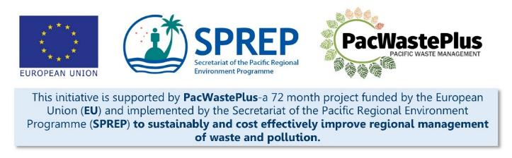

Sustainable Financing for waste management

“Design it Yourself Workbook”

Glossary
Term | Acronym | Definition
Advanced Recovery Fee and Deposit | ARFD | Scheme to fund the collection and management of their waste streams, typically including a consumer refund / buy-back element
Bottle Bill
Container Deposit Legislation / Scheme | CDL / CDS
Deposit Return Scheme | DRS
Extender Producer Responsibility | EPR
Product Stewardship Scheme | PSS
Administration fee |  | Costs for the day-to-day administration of a scheme (e.g., the cost to complete accounting firm, auditors, scheme communication and awareness, etc)
Collection Depot |  | The location households and individuals can access to drop off their eligible items.
Collection Depot Operator |  | The team or individual responsible for operating the Collection Depot.
Deposit |  | Deposit component of scheme, collected on eligible items and reimbursed (refunded) back to a consumer upon return of item for recycling.
Eligible items |  | The items specified by regulation to be included in a scheme.
Handling fee |  | Costs for undertaking logistic and recycling services for a scheme (e.g., shipping/transport, infrastructure and equipment operation, labour, operation of collection depots, etc).
In-Country Materials Processing/Transfer Facility |  | A facility or facilities located in country that collects eligible items from Collection Depots and undertakes pre-processing and export, arranges in-country recycling, or other approved scheme activity.
Legacy Waste |  | Items that were imported before the start of a scheme, so do not have a “deposit” or “handling/admin fee” applied. Found as litter, stockpiled at households, stockpiled at businesses, or still on the shelves / warehouses awaiting sale.
Refund |  | The deposit component of scheme once refunded back to a consumer upon return of item for recycling.
Scheme Governance |  | Body that can be established under scheme legislation to assist with the high-level governance of a scheme to ensure it achieves the goals for the country
Scheme Manager |  | Body that can be established under scheme legislation to assist with the high-level governance of a scheme to ensure it achieves the goals for the country
Seed Funding |  | The revenue required at commencement of a scheme to enable operations (e.g., infrastructure, staffing, management of Legacy Waste)

Introduction
This Design it Yourself Workbook has been developed to guide users through the process of designing and implementing a sustainable financing scheme for Waste Management. These schemes have several names, including Advance Recovery Fee and Deposit (ARFD), Product Stewardship Schemes (PSS), Container Return, Container Deposit, or Bottle Return Schemes, or Extended Importer / Producer Responsibility.
For simplicity in the workbook, we will use the term ARFD, or a “scheme”.
The broad goals of an ARFD Scheme are to improve rates of recycling through the provision of two elements:
- an incentive for consumers to recycle (by providing an immediate financial reward (the refund of their “deposit”) when they drop eligible items at a depot), changing behaviour away from littering, burning, or disposing to landfill
- a self-sustainable funding source for governments and recycling/transfer facilities to undertake the collection, transport, processing, and export/recycling of recoverable materials (using the “fee” component which is calculated as the true cost of recycling each eligible item), providing an economically viable ability to undertake recycling/transfer activities long term, not reliant on variable government funds.

There are a range of policy and regulatory solutions to assist improve waste management in a country; ARFD schemes are one option, others include: single use plastic importation bans, pre-paid bags, kerbside recycling collection, importation quality standards, behaviour change initiatives, etc. The PacWastePlus Decision Support Tool may assist to identify and assess appropriate solutions for the local context.
This Workbook is for users who have already identified an ARFD as a possible solution to improve recycling and assist with waste management in their country and seek to move forward to investigate the feasibility of the scheme, communicate with decision makers, and design an appropriate scheme to suit the specific context of their country. This Workbook is designed to assist users through the process, to design and implement a successful, ‘evidence-based’ ARFD.
Some users of this Workbook may have already investigated ARFD schemes in other PICs or around the world, may have held high-level consultation with decision-makers, or may have commenced scheme design and planning. The information gained from these exercises are relevant and will provide excellent background - but it is recommended to work through this Workbook from the beginning to ensure previous assessments did not miss any important components or collection of relevant data to assist making evidence-based decisions.
This Workbook assumes a general background understanding and awareness of ARFD schemes – it does not provide information on the background or benefits of an ARFD Scheme or information how they work. For this background information please visit the following links or contact PacWastePlus.

- Factsheet describing ARFD schemes https://pacwasteplus.org/resources/advanced-recovery-fee-deposit-systems/ | 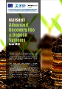
- Video resource illustrating key components of schemes - https://pacwasteplus.org/resources/understanding-advance-recovery-fee-and-deposit-arfd-scheme/ | 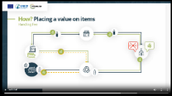
- Video resource highlighting components of successful schemes - https://pacwasteplus.org/resources/sustainable-financing-for-waste-management-study-tour10-key-elements-that-make-a-successful-scheme/ | 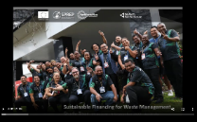

Who Can Use This Workbook
This Workbook can be used by anyone seeking to design an ARFD scheme to be set in legislation or regulation. Global data shows schemes that are empowered by legislation have a greater chance at success over voluntary schemes. If a voluntary scheme is sought, some of the guidance in this Workbook will be relevant – but the purpose of this Workbook is to implement a scheme that will be empowered by legislation.
This Workbook will be of value to by any individual or group involved in the design of an ARFD scheme, for example:
- Government representatives investigating the feasibility of an ARFD scheme or who have been tasked with developing a scheme
- A Working Group tasked with developing a scheme, or contributing to one or more steps of the 21-Step Pathway
- Private Sector or NGO representatives seeking to assist with the design of an ARFD scheme, or contributing to one or more steps of the 21-Step Pathway

How to Use This Workbook
Designing and implementing a successful, evidence based ARFD is a multifaceted process, requiring the collection of data, undertaking meaningful stakeholder consultation, and acknowledging and incorporating differing views to make decisions to meet the specific local needs. It may feel like a daunting process. The 21-Step Pathway (Figure 1) breaks the process down into logical, manageable steps.
This Workbook is designed to assist users through each of the 21 steps, at a self-managed pace. Each step on the 21-Step Pathway is a chapter in the Workbook. Guidance material and activities provided includes:
- Background information and a summary of what is involved to complete the step
- Information and consultation recommended to complete step
- Links to resources that can assist
- Tables, templates, and “pros and con” information to assist with the collection of data and comparison of options to enable evidence-based decision making

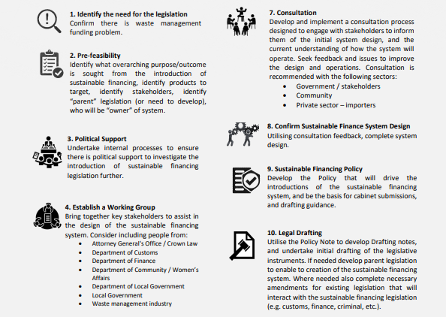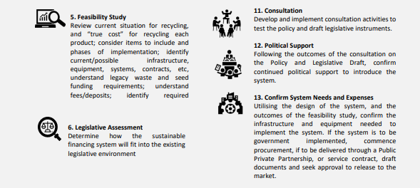

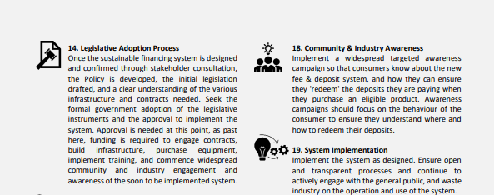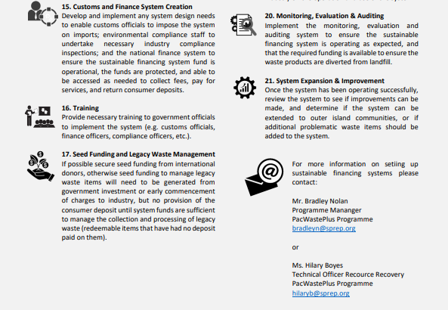
This workbook is designed to be used as a ‘live’ document, meaning users should feel free to jump through different steps based on political needs, data and information availability, and responses from stakeholders. The development of an ARFD is not linear, as review loops exists in various steps and users should not fear taking a step ‘back’, to ensure a clear pathway ‘forward’! Additionally, this workbook is designed to be used in Microsoft Word to keep the document ‘live’. The various tables provided are developed for users to copy and paste, or move elements digitally. Users should feel free to print and utilise the Workbook as needed, but most value will be generated through use as a Microsoft Word file.

Evidence-Based Decision Making
ARFD schemes are unique to an individual country’s local circumstances. There is no such thing as a “one size fits all”.
This Workbook is designed to guide users to collect data to facilitate evidence-based decision making throughout the design of an ARFD scheme. Schemes designed using accurate data and information have an increased likelihood of success as decisions can be made to reflect the actual on-ground context and local situation during the design phase, not relying on ‘guesswork’ or rushed decisions as the scheme is implemented.
Data and information needed for evidence-based decision making is likely to include:
- Data gathered through waste audits and litter assessments
- Information from reliable sources such as customs import and export records data and views from stakeholders (e.g., collected via interviews with in-country recycling/transfer facilities)
- Expert opinions (e.g., from waste management specialists)
- Stakeholder views (including both private industry and the general public).

It is necessary to actively involve stakeholders to gather and share relevant data or have evidence-based discussions (e.g., Customs, Treasury / Ministry of Finance, Justice / AG office, etc). Guidance is provided at each of likely stakeholders and information required to move forward.
Note: some of the data necessary will be sourced from the Private Sector such as importers, manufacturers, in-country recycling/transfer facilities, or exporters. These organisations may hesitate to share data as there may be commercial sensitivity (i.e., they may not want their competitors or communities to see volumes or details of their operations). It is recommended to respect their privacy and find a mutually agreeable way for the data to be obtained – consider using:
- a confidentiality agreement and commitment to only using the data in internal discussions and in a generalised consolidated way (i.e., not able to see individual operations)
- an independent agency who can undertake the generalisation and consolidation (i.e., Department of Treasury / Finance, an accounting firm, or external consultant)

Private Sector importers and in-country recycling/transfer facilities will be key partners in an ARFD scheme. If the trust of these agencies is broken at an early stage in the process it may be difficult to regain.

Material Types Included in Workbook
Schemes in the Pacific have typically focussed on beverage containers, however ARFD schemes can provide a sustainable financing method to manage a variety of End-of-Life items and packaging for recovery targets or for environmental sound disposal. With the correct analysis and using evidence-based decisions, any current waste items may be included in a ARFD scheme. Common waste items that are included in feasibility studies for ARFD schemes in the Pacific include:

- PET bottles (plastic)
- Aluminium cans
- Glass bottles
- Other containers – HDPE, liquid paperboard, tin food cans
- Vehicles – cars, motorbikes
- Heavy Equipment
- Whiteware – washing machine, fridge etc
- Electronics – TV, mobile phone, computers
- Tyres – cars, motorbikes
- Batteries – ULAB, Lithium
- Solar panels
- Used Oil

These items are potentially recyclable as an existing recycling market has been identified in the Pacific region, and/or in-country recycling opportunities exist. For more information on existing recycling market review the PacWastePlus Recycle Market Study.
This Workbook utilises these 12 common items, and assists users seek to understand if an ARFD is feasible solution for their management. Other problem waste materials, such as asbestos or hazardous waste, can also be included for analysis using in the workbook, simply add the material to the supplied templates and utilise the process and system to complete the analysis.

Limitations of the Workbook
This Workbook provides instructions to gather data and design an ARFD scheme following a logical and standardised approach, encouraging the consideration of important factors and understanding pros and cons of certain decisions.
As with ARFD schemes, there is no such thing as a “one size fits all” guidance for scheme design. Please use this Workbook as a guide and amend as necessary to suit the local context . There may be steps or activities that are not relevant, and steps that need more attention and consideration than is provided.
Additionally, there may be different terminology in this guide that is not used locally – i.e., we call Step 4 a “Working Group” – but local terminology may be a “Taskforce Meeting” or “Steering Committee”. This Workbook is designed to be tailored by individual users, amend terminology to be familiar to the local context and use the guide however needed to design a successful scheme.
If there are areas extra information, resources, or assistance is sought please contact SPREP / PacWastePlus.

Global Deposit Book 2022 - https://www.reloopplatform.org/resources/global-deposit-book-2022/

