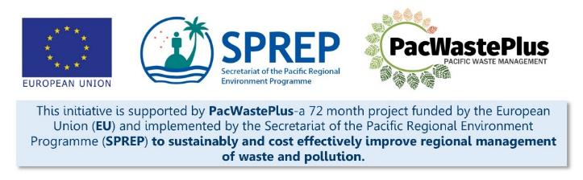
Sustainable Financing for Waste Management: Design It Yourself Workbook

Step 9 - Policy
What Involved to Complete Step  This Step will assist summarise findings, analysis, and decisions made at Steps 5, 6, 7 & 8 into a policy paper. The key purpose of a policy paper is to:  - Summarise proposed scheme and key components for decision makers to review and comment on  - To present the policy position that will form the basis of legal drafting at Step 10  - To describe the policy position that will be consulted on at Step 11 |  | Information / Consultation Recommended to Complete Step  - Findings from the feasibility study and detailed scheme design  - Findings / feedback from political and stakeholder consultation (with communities. Government agencies, and private sector) | Resources Available  Example policy paper / template (request from SPREP / PacWaste Plus)  PacWaste Plus Guidance - Example Table of Contents for ARFD Policy and Drafting Instructions  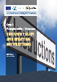
- Policy Paper Drafting | Through completion of Steps above, the design of an ARFD appropriate for the specific context should be complete. The purpose of a policy paper is to summarise the proposed scheme for decision makers to review and comment on.  Use the approved Ministry policy paper template if available or follow the general table of contents as provided. Some details may be identified and included in steps above, copy and paste the relevant information.  Note: in Step 10.1 further commentary on the recommended principles is provided along with exact text from existing schemes in Kiribati, Tuvalu, and Palau.
Example Table of Contents | Policy Text
Purpose/Objective
Outline clear purpose/objective
Scheme Activities
Summary of key activities of scheme
Legislative Implications
New Act / Regulations proposed
Reforms to existing Act / Regulations
Scheme Financials
Establish the dedicated fund and ringfence fees to scheme purposes only
Identify what purposes the fund may be used for
Identify who administers the fund
Specify the role of Customs
Identify who shall pay into the fund and how this will be done
Identify procedures for payment from the fund
Specify how Deposits are paid to consumers
Scheme Inclusions / Eligible Items
Identify the items that will have a ARFD placed on them, ideally with the ability to introduce additional materials or items over time.
Identify the ARFD amount on each item
Identify the deposit amount on each item
Scheme Operations
Establish the scheme
Identify who the financial administrator is for the scheme
Identify who coordinates the physical operations
Specify the physical operations
Identify whether any responsibilities will be contracted to Private Sector operators
Identify which agency is the contract principle (if contracted)
Identify the condition of returned items that will allow payment of Deposits
Require locating of collection depots in locations that ensure recovery target can be achieved
Provide for an exemption with criteria to be met for disposal of recovered items should repatriation be unviable
Specify accessibility (GEDSI) requirements
Offences
Specify offences and penalties
Specify how fraudulent activity will be investigated
Monitoring
Establish the target for recovery
Outline measures for if targets are not met
Auditing
State requirement for auditing
Reporting
Reporting and record keeping requirements for importers/ distributors
Reporting and record keeping requirements for fund administrator
Reporting and record keeping requirements for collection depot and logistical services
Partnerships
Explicit provision for partnerships – Public Private Partnerships, partnership with community organisations
Legacy Waste Management
Building up funding from fees before starting to pay out deposits
Funding for establishing administration and management systems and capability
Funding for addressing legacy items
Funding for establishing depots (for material returns) and processing equipment
Other
Other

- Other Documents | When submitting a policy paper, other documents may be required by the decision makers, including:  - Cabinet Submission Paper – a short (approximately 5 page) version of the policy paper summarising only key aspects  - Cabinet Submission Presentation – Presenting a condensed summary of the purpose / outcomes sought and key aspects of the proposed ARFD scheme for decision makers to understand and comment on. The policy paper presentation may best be undertaken by the political champion, who will likely seek assistance from subject expert  - Pre-consultation paper – to summarise the policy position and seek approval to go out for public consultation (note: a post-consultation Cabinet paper may also be necessary at completion of Step 11 and prior to political endorsement of the scheme)  Use the approved Ministry policy paper template if available or contact SPREP / PacWaste Plus if support required.
Notes for Follow-up / Further Research / Discussions:

