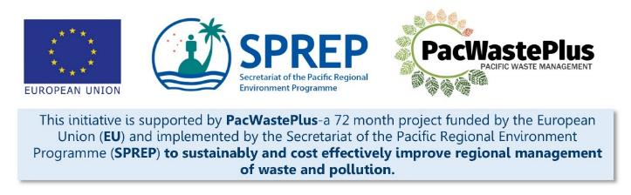
Sustainable Financing for Waste Management: Design It Yourself Workbook

Step 7 – Consultation
What Involved to Complete Step  Once the general feasibility of a scheme has been established, and a high-level assessment undertaken of options for possible scheme design and scheme finances (Step 5), it is recommended to engage with the community, industry, and other stakeholders to involve and seek feedback on scheme design.  Effective consultation and engagement are fundamental for developing ongoing positive relationships with the community and stakeholders. Gone are the days of simply informing stakeholders of the outcome of a project or decision.  Individuals, younger generations, and communities are generally far more informed than ever before and expect, if they are going to be impacted by a decision or activity, that they will be involved in the decision making process.  This Step will assist to prepare for and undertake the stakeholder consultation through the completion of:  - Stakeholder identification – mapping and identifying key stakeholders  - Stakeholder engagement plan, identifying the consultation messages and consultation methods  - Activities to complete inclusive consideration  - Delivery and implementation of consultation  - Reflecting consultation results into scheme design, ensuring feedback is built into and influence scheme design |  |  | Information / Consultation Recommended to Complete Step  - Findings from the pre-feasibility study and feasibility study  - Findings from legislative assessment |  | Resources Available
 |  |  |  |  | Considering GEDSI in ARFD Design  Powerpoint illustrations with speaking notes (request from SPREP / PacWaste Plus) | Developing Project Engagement Plans  Investigative Questioning  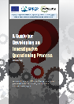
Why engage and involve stakeholders and the community?
- To enable people to be part of decisions that impact on or involve them. Effective participation includes the understanding that the stakeholder’s values, needs, level of awareness, understanding and desires have been taken into consideration when decisions are made. Engagement encourages the public to provide meaningful input and achieve better outcomes. Effective public participation means improved decisions and includes a range of perspectives.
- Gather advice, information and feedback from the community and stakeholders (impacted or interested) on the projects
- Improve awareness and manage expectations
- To give the community empowerment in the management of waste and various waste streams
- Understand the stakeholder’s values to develop more usable, and effective communication and engagement plans
The International Association of Public Participation (IAP2) has developed the participation spectrum to guide consultation and engagement activities.  Understanding the level of engagement for stakeholder groups will guide the activities needed to achieve outcomes sought from the consultation process.  Information sharing techniques (two-way consultation) are recommended as the basis of engagement strategies. Active participation to engage and encourage stakeholders to share their thoughts and opinions will empower stakeholders during the decision making process.  The IAP2 spectrum illustrates differing levels of participation depending on the goals, resources, and levels of concern in the decision to be made.  More information on the IAP2 spectrum can be found in the PacWaste Plus Guide to Developing Project Engagement Plans: Stakeholder Education and Awareness. |  | Participation Spectrum:  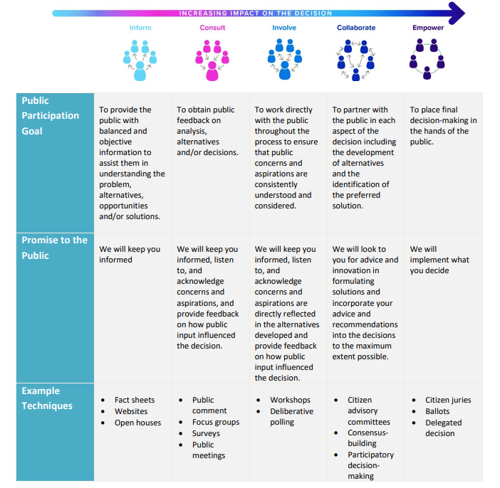
- Stakeholder Identification | Stakeholder identification is the first step in consultation. Stakeholder identification is undertaken to identify organisations and individuals who may be directly or indirectly affected by a scheme, or who may have a specific interest. The result should be a list of all stakeholders, identifying who may have influence on a scheme and who may be impacted by a scheme.  The following table will assist to undertake the stakeholder assessment, and identify specific needs and actions that may be required to complete meaningful consultation. This is a brainstorm activity and is recommended to be done prior to developing the Stakeholder Communication Plan (Step 7.2). Examples are shown in italics. This table can be completed with stakeholder groups or representatives as a brainstorming exercise on a flipchart/butchers paper.  The PacWaste Plus Guide to Developing Project Engagement Plans: Stakeholder Education and Awareness has further details to complete stakeholder identification.
 | During the stakeholder identification exercise it is recommended to specifically consider minority groups such as:  - residents of informal settlements, ethnic minorities  - low visibility due to mobility constraints caused by a physical or mental disability  - groups with non-conforming sexual and gender identities.  The voices of these groups may be commonly overlooked during regular consultation. It may be useful to complete a drawing exercise to identify these groups – first illustrating the core groups, and those who sit on the outer edges. Pay attention to those groups who sit on the outer edges and may be socially excluded due to overlapping disadvantages they face. |  |  | 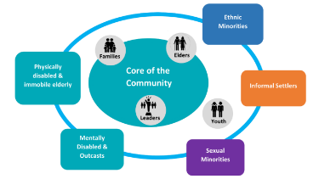
Stakeholder Identification / Analysis Matrix
Stakeholder (List Agencies from Step 2.4) |  | Potential Interest in Project | Influence in Community | Appropriate Level of Participation During Consultation  (Inform, Consult, Involve, Collaborate, Empower) | Specific Needs During Consultation | Actions During Consultation
Example  People with disabilities | Creative Centre (School for People with Special Needs)  Disabled People’s Organisation  Ministry of Education  Deaf/Blind Foundation | Potential to earn income from collection of recyclable items  Possible employment as operators of Collection Depots | Influence in community is generally low so extra effort to consult may be required | Involve  Empower | Extra measures to ensure ability to be included in consultation processes and project awareness:  - Extra effort to ensure engagement  - disability accessible and safe venue  - Support with transport  - Incentive for carers to attend  - Possibility of door-to-door awareness. | - Engage with country Disabled People's Organisation (DPO)  - accommodate specific needs during consultation (see below for examples)

Notes for Follow-up / Further Research / Discussions:

- Project Engagement Plan |  | A Project Engagement Plan is recommended to be developed to guide communications and consultation activities. Taking time to plan the engagement process will help build trust with your audience.  The below template may be used as a brainstorming activity to build this plan, identifying the key topics / interests for the stakeholder groups identified above, and summarise engagement techniques and frequency to meaningfully communicate with that group. Examples are shown in italics. Note: groups identified to have little influence and a high interest may need additional engagement and inclusion supports.  There are many tools and techniques that you can use to engage with stakeholders, depending on the type of participation sought. Examples of communication and engagement tools and methods that may be useful during consultation on an ARFD scheme are included in the table below.  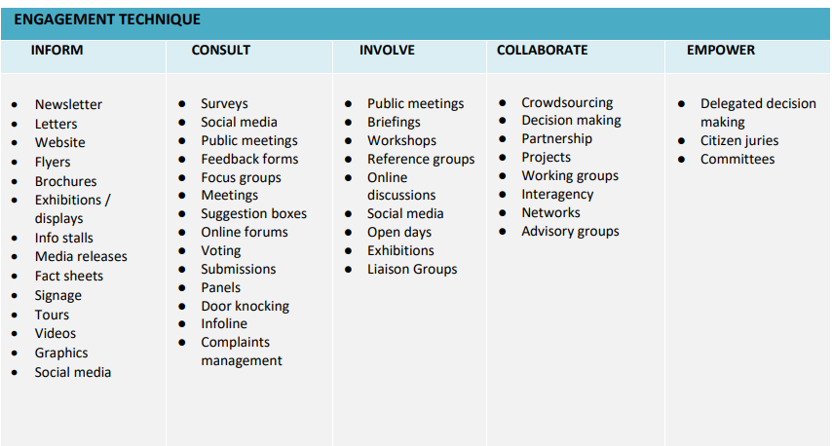
Project Engagement Plan
Stakeholder | Influence / Interest | Key Interest for ARFD  (review Feasibility Study to identify possible factors of interest to group) | Engagement Techniques  (see below for examples to utilise ) | Frequency | Comments
People living with disabilities | Influence: generally low  Interest: high | - Level of Deposit - likely benefit from the financial aspect of the system/scheme  - Value of Fees and Deposit – price of goods may increase, have disproportionate impacts on lower-income groups  - Collection Depot design and operation - may have additional mobility needs  - Scheme advertising - may have additional communication needs | Inform and Involve: Special invites to public meetings and briefings. Brochures and Public meetings.  Consult: Door knocking and/or use of local DPO or disability representative to disseminate information directly  Collaborate and Empower: involve in decision making for design/operation of depots, empower to partner in scheme (i.e., operate Collection Depot)  Additional communication resources required:  - Recording in local language explaining the scheme  - Enlarged text brochures with pictures  Specific needs:  - Disability accessible meeting areas  - Short disability awareness to overall community  - Incentive for carers to accompany to meetings  - Separate additional meetings  - Door to door contact  - Person with a disability accompanying team | - Prior to feasibility study community engagement to establish needs and preferences to ensure groups are included  - During feasibility study and scheme design
Women | Influence: moderate  Interest: high | - Level of Deposit - Will likely benefit from the financial aspect of the system/scheme  - Overall change to waste management - Women already have multiple caring and community responsibilities  - Collection Depot design and operation - may have limited time (cannot access during the day due to caregiving responsibilities | Consult and Involve:  - Community notice board  - Local women’s committees or clubs  - Local women’s representative  - Church announcements  Specific needs:  - Separate additional meetings in women’s market space  - Safe space and activities for accompanying children during meetings  - Women facilitators

- Activities to Complete Inclusive Consultation | To conduct inclusive consultation and engage with all members of the community, including those with different needs and requirements, it is recommended to consider including the following activities (or other ones specific to the local country) during the consultation process.  Activities Comments Required Y / N Check When Complete  Make contact with a Disabled People’s Organization (DPO). Hold a stakeholder meeting and seek guidance and potential of hiring a person with a disability to accompany future community consultations (keep notes of meeting for future reference – a written agreement or MoU may also be sought for this service support)  Get an updated list of DPO representatives in communities from disability CSO of social affairs ministry. This list will serve as a reference for future project implementations.  Establish community communication with the leaders and existing committees or women’s disability or youth representatives  For communities or village consultation, an initial visit is recommended to inform the chief of the village or leader of the proposal. It may also be appropriate for this meeting to also include the community council, disabled person’s representatives, women’s representative, and youth representatives.  Select a neutral space within the community that all groups can access for meetings and walk through the space with a person with disabilities in advance to check accessibility.  Ensure that the entry to the venue and all meeting room(s) are accessible, including ramps, handrails and doorways that are wide enough for a wheelchair.  Make sure there are accessible toilets close to the meeting room and the selected room should be large enough to allow enough space for people to move freely, including for wheelchair users.  Set up working group and delegate roles to each member in the event of the consultation.  Working group to come up with goal or objectives for the community consultation: What they hope to achieve.  Working group to develop a plan of how the community consultation will be implemented, considering language barriers: interpreters and vulnerable groups. Whether to do the consultation as an open group discussion with certain representatives from different groups to speak or a focus group discussion.  Plan to have men, women and disabled persons representative facilitators in the meetings.  Ensure all facilitators using any form of visual aids are prepared to describe any pictures, photographs or diagrams so as not to exclude people who have difficulty seeing. Ensure speakers have planned the timing of their presentation accordingly.  Select and develop the data collection tools for consultation.  - Participant register outlining the specific groups that exist in the community and that attend meetings.  - Surveys (Pre and post consultation survey/ baseline, midline and end line surveys)  - Focus group discussion questions.  - One on one interviews with selected members of the community.  - Community Mapping  Develop a mechanism for community feedback/complaints and questions and how this will be managed after the consultation  Community is contacted well in advance to inform them about community consultation and the aim of this activity.  Community Consultation is implemented according to plan by working group with the assistance of existing committee within the community. Use inclusive language. For community members that do not understand the language have an interpreter to translate what is being said.  Data collection tools are utilised, and the data collected compiled by working group to determine the next steps of the project.  Other  Other
Notes for Follow-up / Further Research / Discussions:

- Delivery and Implementation of Consultation | Deliver the Project Engagement Plan to ensure meaningful consultation with all identified stakeholders. As identified, different engagement techniques, methods, and specific activities will be required to target each group. Contact SPREP / PacWaste Plus if you seek powerpoint slides or specific guidance on developing resources for identified engagement sessions.  Further guidance is provided in the PacWaste Plus resources:  - Guide to Developing Project Engagement Plans: Stakeholder Education and Awareness  - Guide for Considering GEDSI in ARFD Design  - Guide for investigative questioning
Regardless of the engagement technique identified for different stakeholders (e.g., facebook animation and online survey, community session, or door-to-door consultation), consultation topics may follow a similar theme. An example of topics may include:
- Purpose of ARFD scheme – what problem is it trying to solve and key outcomes sought (i.e., improve rates of recycling across the country, provide for self-sustainable recycling industry)
- Summary of key scheme components:
  - Collection of a Fee and Deposit on identified items
  - Fee and Deposit held in a dedicated fund, used only for purpose of scheme
  - Deposit component returned to consumers once items dropped off to a Collection Depot
  - Fee component used to undertake the collection, transport, processing, and export/recycling of recoverable materials
  - Scheme infrastructure will include Collection Depots and Materials Processing Facility – summarise options
- Seek to gain feedback on:
  - Overall purpose of the scheme
  - What important to them / their community to participate in the scheme
  - Level of Fee/Deposit
  - Scheme infrastructure – views on different options Collection Depots
  - Scheme accessibility

If undertaking Consultation sessions in communities or village, be mindful of village protocols and appropriate hierarchies and communication methods.  Community meetings may require segregated groups according to male / female, youth / elderly etc to ensure all concerned parties are provided with an environment where they can have their say.  Special attention is recommended to the timing of meetings to allow for maximum participation of community members.  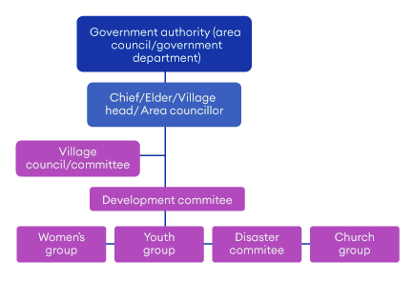 |  | 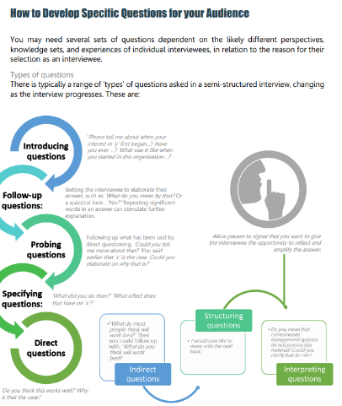
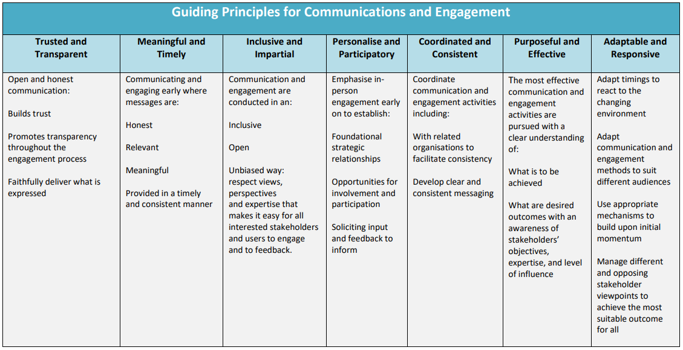

The following illustration may be useful during community consultation sessions. Print off and hand out so stakeholders can see scheme as a whole and invite them to write down what is important to them at each stage of the proposed scheme (below find some conversation starters / potential topics for the different stakeholders / components of the scheme)
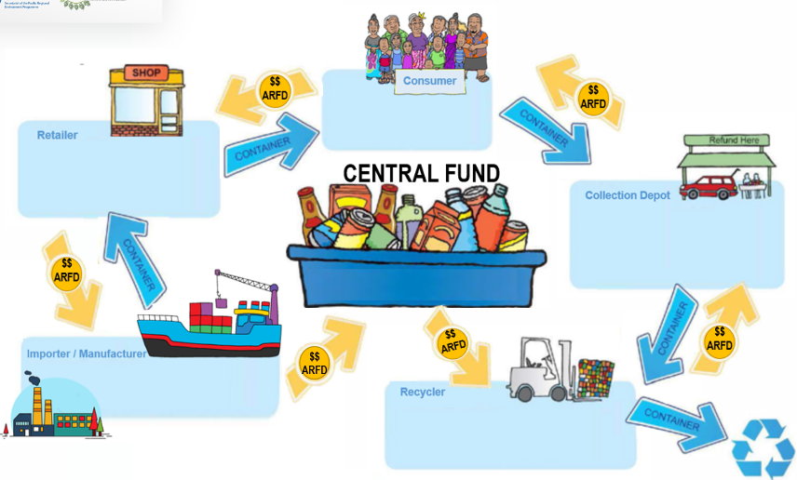

 | 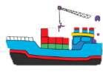
Potential Topics of Interest | Items proposed for inclusion  Proposed level for Fees and Deposits  Purpose of scheme  How to pay ARFD  How fund will be keep secure and used only for intended purpose  Who manages scheme  Who will scheme ensure recycling activities occur | Items proposed for inclusion  Proposed level for Fees and Deposits  Purpose of scheme  How to pay  How fund will be keep secure and used only for intended purpose | Items proposed for inclusion  Proposed level for Fees and Deposits  Purpose of scheme / how benefit their household and community  How people with different needs and requirements can access Depots  Employment opportunities  How to claim refund /access Depots  How fund will be keep secure and used only for intended purpose | Items proposed for inclusion  How they will be involved / how interact with existing recycling operations  Proposed level for Fees and Deposits  Purpose of scheme / how benefit their business  How fund will be keep secure and used only for intended purpose

- Engagement Evaluation and Reflecting Feedback into Scheme design | A key step during consultation is to record community comments and feedback on the scheme and components on scheme design and ensure feedback is built into and influences scheme design.  The following table may be used to consolidate findings from the consultation and summarise the specific feedback on the scheme or scheme components. It is recommended to consider this feedback in the scheme design, and report the results of how the feedback was considered (or, as appropriate, not considered due to certain factors) back to stakeholders who raised the suggestion / question. It is recommended to give this task to a specific person on the Working Group and ensure this activity is undertaken within an appropriate timeframe.  Stakeholder Group Engagement Technique Summary of Discussion Specific Feedback on Scheme or Components of Scheme Design How Feedback was / will be Considered in Scheme Design Responsible Person to Report Back to Community
Notes for Follow-up / Further Research / Discussions:

