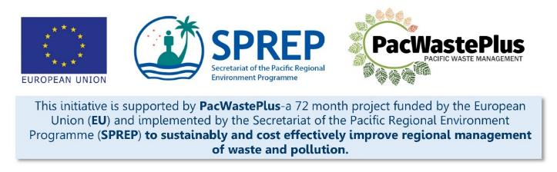
Sustainable Financing for Waste Management: Design It Yourself Workbook

Step 4 - Forming a Working Group
What Involved to Complete Step  ARFD schemes are not just a “waste” or “environment” initiative and should not be left to just waste and environment staff to design.  To operate effectively and to provide meaningful social benefits such as employment and income opportunities for marginalised groups, schemes require partnerships with departments such as customs and finance, and will benefit from the views of women’s/community affairs, local government, youth, recycling businesses/association, NGOs, and Private Sector importers and retailers during scheme design.  As such, a multi-agency Working Group is recommended to be established to be responsible for scheme design and consultation.  The representative from the Ministry or Department of Women’s Affairs (or equivalent) can provide valuable perspective during scheme design and can provide introductions to the community, such as women’s associations, and provide advice on mainstreaming gender throughout the design and development of the scheme.  Involving Private Sector importers is recommended. There are options to consider for when to bring these agencies to the discussion:  - initially identify and bring together only appropriate Public Sector (government) agencies, to ensure they clarity on the issues and goals for a scheme. Once there is cohesion and shared understanding amongst the Public Sector, invite Private Sector / industry representatives to join.  OR  - identify and invite Private Sector importers / industry groups from the onset. Private Sector importers / industry representatives are key stakeholders and partners in a successful ARFD scheme and are recommended to be a key part of the Working Group to help in its design. If these groups are “brought to the table” early, and assist with Step 1 and 2, they may understand the scheme and see the environmental and social benefits it can provide for the country. If these groups are not empowered during scheme design they may not understand what is being proposed and see the scheme as a “tax” or feel they will be carrying un unfair financial burden and may challenge the scheme at later stages.  Regardless of the approach taken, forming a multi-agency Working Group and agreeing to a clear mandate and roles and responsibility is an important step in ARFD scheme design.  This Step will assist to:  - Identify partners and form a Working Group  - Form the Working Group and determine agreed role and function  - provide decisions, topics of discussion, and activities for the Working Group to undertake  Findings / recommendations from the Working Group should inform scheme design and policy/legislative drafting |  |  |  |  |  |  |  | Resources Available  PacWaste Plus ARFD Factsheet  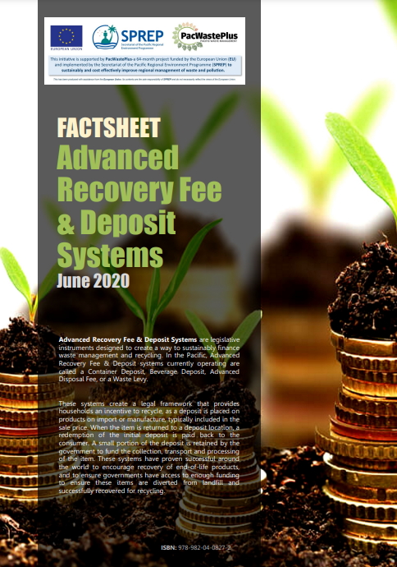  Editable ARFD Factsheet (request from SPREP / PacWaste Plus)  PacWaste Plus Guide for Considering GEDSI in ARFD Design  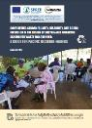  PacWaste Plus Guide Key Questions and Decisions for ARFD Design  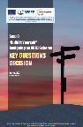
- Identify scheme partners |  | In Step 2 we illustrated, at a high-level, how a scheme may operate, and we identified the key players. It is these key players that should be considered to be part of the multi-agency Working Group.  Consider the key players below and add any others identified above – i.e., Local Government? AG Office? Write in the box provided who may be appropriate to represent that group during the design of the ARFD.
 |  |  |  |  |  |  |  |  |  | OTHER
What agency may be appropriate to represent importers and manufactures during ARFD scheme design? | What agency may be appropriate to represent retailers during ARFD scheme design? |  | What agency may be appropriate to represent communities during scheme design? | What agency may be appropriate to represent recyclers during scheme design? | What agency may be appropriate to represent marginalised during scheme design? |  | Is Finance required to be represented during scheme design? |  | Is Customs required to be represented during scheme design? | What other stakeholders should be represented during scheme design? (e.g., Attorney-General / Justice, Local Government, Community / Women’s Affairs, NGOs)
When considering who to involve in a Working Gorup, it may also be helpful to consider the role certain groups may have in scheme operation. The following table may be useful to identify the parties that will add value to scheme design.
Role | Organisation | Responsibilities | Example Organisation | Example Responsibilities
Collecting the ARFD |  |  | Customs | Places the ARFD on imported items and directs to the appropriate fund.
Importation of items |  |  | Importers | Pays ARFD  Reports on products imported
Fund Administrator |  |  | Treasury / Finance | Manage and monitor the fund  Financial reporting to Cabinet, working group
Scheme financial administration |  |  | Treasury / Finance | Manage and monitor the finances of the scheme  Financial reporting to identified authority, working group  Consider also Department of Environment role in financial administration
Management of Physical Operations |  |  | Environment | Reporting to identified authority, working group  Education and awareness
Collection Depot operator/s |  |  | Retail, Department of Environment, NGO, Private Sector | Accept returned items  Issue deposits  GESDI requirements  Data Collection / Reporting
Logistics in-country |  |  | Shipping / Trucking Companies | Transfer returned items to Recovery Centre/Waste Facility  Reporting to Management of Physical Operations for claims
Logistics international |  |  | Environment / Recyclers Exporters | Arrange packing and shipping of processed returned items.  Arrange necessary documentation for shipping of waste materials.  Reporting to Management of Physical Operations for claims
Materials Processing / Recovery Centre |  |  | Environment | Receive returned items, process as required.  Reporting on Physical Operations
Monitoring |  |  | Treasury / Finance  Environment | Finances  Achievement of targets  GESDI
Auditing |  |  | Auditor General | Finances audited by identified agency and provided to identified authority

- Form the Working Group | Once stakeholders have been identified, engage with them though the standard government process. Consider the following:  - The Political Champion (identified in Step 3) meets, formally or informally, with the Minister, Secretary or Director(s) of the key identified agencies to provide an overview of the proposed ARFD scheme, to articulate what is being sought from their Ministry or Department’s involvement in the Working Group. Provide factsheet / information material and seek suggestions for which agency staff could sit on the Working Group, and request time is allocated for their involvement.  - A formal written letter of invitation briefly outline the following:  - purpose of ARFD scheme, purpose of the Working Group  - anticipated commitment required  - date of first meeting  - key contact for response and questions.  Note: It is recommended that being on the ARFD Working Group should be formally added to the annual workplan for the dedicated staff member(s) so their attendance can be part of their monthly activities and not an “added extra” that will commonly get pushed to the side as the “real job” takes over. |  |  |  |  | Maintaining momentum – ways to keep the Working Group engaged may include:  - Meeting regularly  - Assign responsibilities and meaningful task  - Share progress reports  - Celebrate success
- Determine agreed role and function | It is recommended for the Working Group to agree to a clear mandate and roles and responsibility. Consider establishing a Terms of Reference (ToR)/ Memorandum of Understanding (MoU) for the Working Group to set out:  - Purpose / Vision for ARFD for country  - Purpose / Objectives of Working Group – so there is a clear, shared understanding of what the purpose of the groups is  - Scope and Parameters of ARFD and/or Working Group – so there is a clear, shared understanding of what the group is expected to undertake and any parameters to consider in decision making  - Values – confidentiality, how communicate with each other, respect others views and perspectives  - Expectations – time commitment, data requests from department, what activities/tasks may be required, decisions needed to inform the policy  - Membership and Term – how to give up seat, how to select replacements  - Meeting schedules and location
A Working Group Terms of Reference may follow this framework:
 | Terms of Reference Text | Example Text
Title |  | [COUNTRY NAME] ADVANCED RECOVERY FEE AND DEPOSIT SCHEME WORKING GROUP  TERMS OF REFERENCE
Purpose / Vision of ARFD |  | The goals of an ARFD Scheme in [COUNTRY] is to improve rates of recycling through the provision of two elements:  - an incentive for consumers to recycle (by providing an immediate financial reward (the refund of their “deposit”) when they drop items at a depot), changing behaviour away from littering, burning, or disposing to landfill  - a self-sustainable funding source for governments/recyclers to undertake the collection, transport, processing, and export/recycling of recoverable materials (using the “fee” component which is calculated as the true cost of recycling), providing an economically viable ability to undertake recycling activities long term, not reliant on variable government funds  [Other goals of the ARFD scheme include (from Step 1)]
Purpose / Objectives of Working Group |  | To work as a collective group with diversity of perspectives towards the design and implementation of an ARFD for [country].  [add specific requirements… i.e.,  - To share data and make decisions on behalf of [country]  - To lead during Consultation and Political liaison tasks]
Scope and Parameters |  | The ARFD will be implemented as a Regulation under the Waste Management Act 2010 and Scheme Finances will be managed by the DOF under the Finance Act 2001  The Working Group will determine feasibility and make decisions behalf of [country] on design of scheme relevant to:  - Collection depot design  - Scheme operation  - Outer island involvement  - Setting Scheme Fees and Deposits
Values |  | Decisions made to benefit country – environmental, social, and financial – not self-serving interest  Particularly consider marginalised groups in decision making  Working together in equality - Trust, kindness, positivity, and respect for one another
Expectations |  | Members time commitment will be xx hrs per month  Relevant data will be shared from department as requested  Complete assigned activities/tasks in good will and transparency  Decisions made to benefit country
Membership and Term |  | Membership is extended by invitation from [add Lead Organisation/Project Lead]  Members may recommend others to fill gaps of national/community representativeness  Government Representatives - Membership is compulsory and assistance with the design of the ARFD is part of annual workplans and  Private Sector - Membership is voluntary. Meeting attendance is by good will, rather than by obligation.  A membership list will be developed and maintained for transparency
Meeting schedules and location

- Decisions and topics of discussion for Working Group | It is recommended the Working Group assists working though the activities in this Workbook, in particular Steps 1, 2, 5, and 8, and make the necessary decisions to design and implement an effective ARFD.  Assigning a timeframe and topics for Working Group meetings may be useful to keep the Working Group engaged and focussed on scheme design.  Use the following table to pre-determine topics for Working Group meetings:  Topics Example Topics Resources / Step  Meeting 1 Introductions Introduction to ARFD Discuss and confirm ToR – sign on Discuss Step 1 and review data gathered – review information and complete recommended activity to determine purpose of the scheme Identify opportunities and issues for scheme to consider Step 1 Factsheet describing ARFD schemes Editable Factsheet Video resource illustrating key components of schemes Video resource highlighting components of successful schemes  Meeting 2  Meeting 3  Meeting 4  Meeting 5
 | Notes for Follow-up / Further Research / Discussions:

