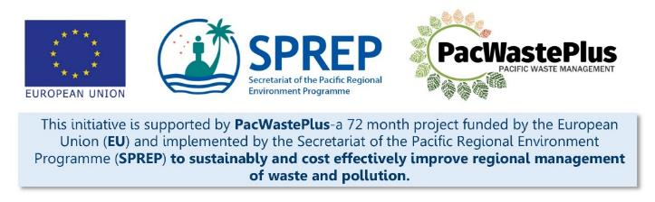
Sustainable Financing for Waste Management: Design It Yourself Workbook

Step 3 - Political Support
What Involved to Complete Step  In the previous steps, data was gathered to gain an understanding on the current situation for waste management and opportunities on how an ARFD may provide a solution to improve materials recovery and recycling.  It is recommended at this stage of the process to get the support of political decision makers on a proposed scheme and gain approval to move forward with scheme design. Having a political “champion” to lead and support the scheme has proven to be a key component of success in most countries that have implemented a scheme, as high-level support is able to influence and “smooth the way” for future steps.  - Benefit of having Political Support - ARFD schemes will require new legislation, a introduce new charge on imported goods, will introduce a significant change to existing waste management processes, and will involve many stakeholders and partners (importers, Treasury / Finance, Customs, communities etc) – touching almost all households and businesses . As such they can be politically charged – with some stakeholders not able to see the benefits at the beginning. A political champion who can assist with stakeholder liaison, consultation (Steps 7 and 11), and lead the political endorsement (Step 12) and legal adoption (Step 14) phases will be a valuable partner in scheme design.  Equally, there are reciprocal benefits to politicians to support an ARFD:  - Benefit to Politicians - ARFD schemes have a proven record to benefit countries – significantly changing existing waste management practices and enabling a financially viable long-term recycling programme that all communities are able to access, creating meaningful employment, and providing an additional income opportunity for marginalized groups. As such – political leaders may see the introduction of a scheme as an excellent initiative to support and have on their portfolio.  Note: the earlier political support is obtained the better. It is recommended to involved political decision-makers while gathering the data in Steps 1, when reviewing existing waste management situation and determining goals, and at Step 2.  This Step will assist to identify and liaise with political decision-makers and receive political support to further investigate the introduction of an ARFD scheme:  - identify and liaise with political champions  - develop am ARFD briefing paper  - gain support for next steps |  |  |  |  | Information / Consultation Recommended to Complete Step  - Consultation with Secretary / Head of Ministry to identify political champion  - Consultation with political champion |  |  | Resources Available  PacWaste Plus ARFD Factsheet  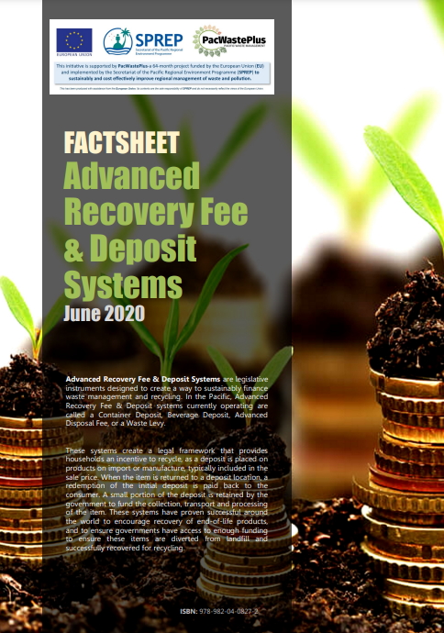  Editable ARFD Factsheet (request from SPREP / PacWaste Plus)  PacWaste Plus ARFD Scheme Illustration Video  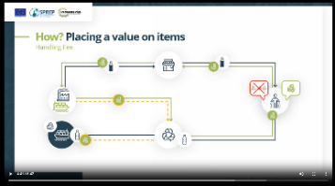  PacWaste Plus ARFD Scheme Video (highlighting components of successful schemes)  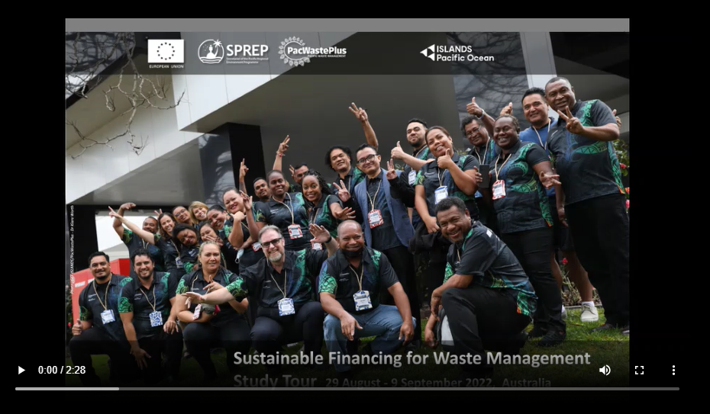
- Identify and liaise with a Political Champion | Discuss with the Secretary / Head of Ministry and together identify current political leaders and consider who may have the background interest to support an ARFD scheme. The Minister for Environment is the usual political champion in other schemes in PICs, but that is not the only option.  Consider what Secretaries, Ministers, or even the Prime Minister may have interest to support a scheme – gather background information and previous support or public statements on topics relevant to ARFD – i.e., waste/environment, plastic pollution, circular economy, inequality of waste collection, need for meaningful jobs, etc. ARFD schemes can also directly support Climate Change initiatives which can be another motivator for political support for a scheme.  Consider the pros and cons on the options for the political champion. There can be more than one political champion – a partnership between Environment and Finance may be a good combination.
Minister Name:
Previous support for initiatives or statements on topics relevant to ARFD – i.e., waste/ environment, pollution, inequality of waste collection, meaningful jobs, Climate Change, etc
Pros / cons on whether a likely political champion
Once a likely political champion(s) is identified, contact the office of that Minister though the standard government processes – i.e., through letter, meeting request, or both. |  | During the initial letter and/or meeting it is recommended to provide cover these topics:  - summary of current waste management situation  - What is ARFD and how might it benefit the community and waste management? (the PacWaste Plus video and factsheet resources may be useful to provide a general overview)  - summary of the data collected in Step 1 and recommendation to undertake the “what seek to achieve” priority analysis exercise (Step 1.4) together  - describe the expected process to implement an ARFD (i.e., the 21 Steps) where the political support may be required, i.e.:  - establish a multi-agency Working Group, and gain support of key agencies (i.e., Finance) to be involved  - progress with a Feasibility Study  - consultation  - political endorsement  - etc  - discuss timeframes and how the political champion seeks to be involved – schedule regular meetings, briefing notes, attendance at meetings, etc  - discuss next steps - documents needed and any information requests
- Develop Briefing Paper | The Political Champion may request a briefing paper that they can table at the next sitting of Cabinet or Government Advisor Committee etc.  This paper would be intended to briefly describe what an ARFD is and what the implications may be for the country. A briefing paper is typically less than 5 pages. Use an approved Ministry template or follow the following general format:  Briefing Paper Text Example  Purpose Seeking to implement an ARFD scheme to improve rates of recycling across the country and enable a “product stewardship” model to provide a shared responsibility for waste management (across importers, consumers, and the government)  Background A scheme would require provision of two elements: - an incentive for consumers to recycle, changing behaviour away from littering, burning, or disposing to landfill - a self-sustainable funding source for governments/recyclers to undertake the collection, transport, processing, and export/recycling of recoverable materials,. Scheme in operation across the world and in 5 PICs and are a proven way  Benefits Summarise findings from waste audit and litter assessment  Legal Considerations Summarise findings from legal assessment  Financial and Economic Considerations Scheme designed to provide an economically viable ability to undertake recycling activities long term, not reliant on government funds Summarise any possible government assistance for scheme implementation  Other Considerations  Comments and Conclusions  Recommendations Establish a multi-agency Working Group with representatives from the following government ministries: finance, women’s/community affairs, customs, and local government. Progress with a Feasibility Study to explore the feasibility of an ARFD
- Gain support for next steps | Discuss with political champion the next steps for the design of an ARFD, which is likely to include:
 | 1. Support to establish a Working Group  Having political support for the multi-agency Working Group will assist with the key partners to commit to the Working Group and dedicate the required time to assess scheme feasibility and scheme design/development.  Ask the Political Champion to liaise, formally or informally, with their counterparts from other Ministries (Finance, Women’s Affairs, Customs, etc) regarding the proposed scheme and request the dedication of a staff member(s) to meaningfully represent their department at the Working Group. A formal written letter of invitation is also recommended.  The Political Champion’s attendance at Working Group meetings may provide valuable support for the development of the scheme. |  |  | 2. Support progress with a Feasibility Study  One of the most substantial steps in the 21-Step Pathway is the Feasibility Study, where detailed data will be gathered and analysed to determine the feasibility of an ARFD, and where the mechanics of how a scheme may work will start to be considered.  Political support for the completion of a Feasibility Study may include:  - Dedicate budget to have an external consultant to complete the Feasibility Study on behalf of the government  - Dedicate the time of government departments to contribute to the time the Feasibility Study  - Formally request relevant data from agencies such as customs and Private Sector recyclers (considering the option for developing a confidentiality agreement etc as discussed above)
 | Notes for Follow-up / Further Research / Discussions:

