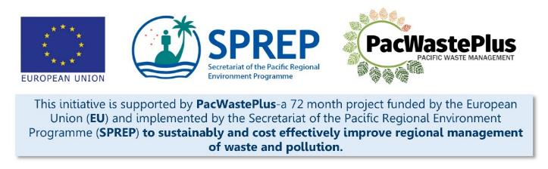
Sustainable Financing for Waste Management: Design It Yourself Workbook

Step 21 - System Expansion and Improvement
What Involved to Complete Step  Once the scheme has commenced operation, it is recommended to undertake regular reviews of scheme operation and global recycling opportunities to consider if expansion or improvement can be made. |  | Information / Consultation Recommended to Complete Step  - Data from scheme monitoring and evaluation | Resources Available  Developing Monitoring and Evaluation Plan: A Guide for Project Designs  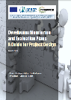
- Analyse Data | Analyse data collected in Step 20 to understand opportunities for scheme expansion or improvement.  Expansion or improvement may include:  - Extending geographic scope - to outer island or remote / rural communities through provision of Collection Depots  - Extending scheme inclusions - Adding additional items for collection by the system  - Improving accessibility or removing barriers for communities to participate in scheme  Contact SPREP / PacWaste Plus if assistance is required to develop scheme specific data evaluation templates
Notes for Follow-up / Further Research / Discussions:

