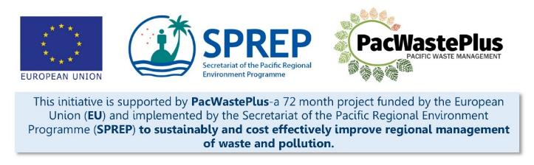
Sustainable Financing for Waste Management: Design It Yourself Workbook

Step 20 - Monitoring & Evaluation, and Auditing
What Involved to Complete Step  Implement a monitoring, evaluation, and auditing system to ensure the scheme is operating as expected, and that the required funding is available to ensure the identified scheme activities are undertaken.  This Step will assist to  - evaluate the system and determine if it's meeting the objectives and targets set out in Step 8 and 9  - provide provision for making information accessible to the public, and a plan for scheduling public information updates on the performance of the scheme |  |  | Information / Consultation Recommended to Complete Step  - Findings from the feasibility study and detailed scheme design  - Findings / feedback from political and stakeholder consultation (with communities. Government agencies, and private sector)  - Results from policy and legislative approval | Resources Available  Complete a Waste Audit  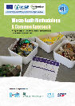  Complete a Litter Survey  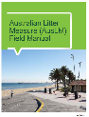 | Developing Monitoring and Evaluation Plan: A Guide for Project Designs  Monitoring and evaluation resources (request from SPREP / PacWaste Plus)
- Record keeping and Monitoring Procedures | Implement the agreed record keeping and monitoring procedures to track and evaluate scheme performance
Monthly / Annual Recycling Rate
Items in Scheme | Items Imported | Items Collected at Depots | Items Recycled | Items Exported | Recycling Rate %  (Imported / Recycled + Imported)
PET bottles (plastic)
Aluminium cans
Glass bottles
Other containers – HDPE, LPB, tin food cans
Vehicles
Heavy Equipment
Whiteware
Electronics
Tyres
Batteries
Solar panels
Used Oil

Litter Assessment
Using the same methodology as the assessment in Step 1, it is recommended to complete regular litter assessments to monitor scheme performance against litter targets
Litter Assessment  Baseline Assessment |  |  |  |  |  |  | Litter Assessment  Follow-up Assessment – 3 months, 6 months, annual |  |  |  |  |  | Difference (+ / -)
Items | Results / Findings (items collected) |  |  |  | Total | Percen-tage | Results / Findings (items collected) |  |  |  | Total | Percen-tage | Volume Change (Follow-up –Baseline | Percent Change (Volume Change / Baseline %)
 | Sample Area 1 | Sample Area 2 | Sample Area 3 | … |  |  | Sample Area 1 | Sample Area 2 | Sample Area 3 | …
PET bottles (plastic)
Aluminium cans
Glass bottles
Other containers – HDPE, LPB, tin food cans
Vehicles
Heavy Equipment
Whiteware
Electronics
Tyres
Batteries
Solar panels
Used Oil

Landfill Assessment
Using the same methodology as the assessment in Step 1, it is recommended to complete regular landfill audits to monitor scheme performance against waste disposal targets
Items Disposed to Landfill  Baseline Assessment |  |  |  |  |  |  | Items Disposed to Landfill  Follow-up Assessment – 3 months, 6 months, annual |  |  |  |  |  |  | Difference (+ / -)
Items | Results / Findings (weight) |  |  |  | Total | Percen-tage | Results / Findings (weight) |  |  |  | Total | Percen-tage | Volume Change (Follow-up –Baseline |  | Percent Change (Volume Change / Baseline %)
 | Week 1 | Week 2 | Week 3 | Week 4 |  |  | Week 1 | Week 2 | Week 3 | Week 4
PET bottles (plastic)
Aluminium cans
Glass bottles
Other containers – HDPE, LPB, tin food cans
Vehicles
Heavy Equipment
Whiteware
Electronics
Tyres
Batteries
Solar panels
Used Oil

- Social Monitoring |  | Implement the agreed record keeping and monitoring procedures for collection of data on users of the scheme according to business /private / gender / level of mobility. This information allows the understanding of users of the scheme (and who is missing out).  The following templates may be used as a starting point or contact SPREP / PacWaste Plus if assistance is required to develop scheme specific data collection templates  Users of Collection Depots Number of Items Dropped off Type of Items dropped off (beverage, e-waste, etc)  Gender  Male  Female  Non binary  Not disclosed  Age  Under 18  19-39  40-59  Over 60  Mobility level  No visible limitations  Visible limitations  Wheelchair  Transport method*  Car  Motor bike  Push bike  Public bus  Taxi  Walk  Other  * may be an appropriate proxy to illustrate level of income  How many communities in country with more than 1,000 people  Target Performance after 3 months Performance after 6 months Performance after 12 months … Comments  How many communities with more than 1,000 people have access to a Collection Depot  Percentage of communities who have access to a Collection Depot
- Evaluating and Reporting Against Targets |  | Implement the agreed activities to evaluate and report the scheme against the intended targets  The following template may be used as a starting point or contact SPREP / PacWaste Plus if assistance is required to develop scheme specific data collection templates  Goals of the Scheme Baseline Target Performance – 3 months Performance – 6 months Performance – 12 months … Comments on Performance Against Targets  E.g., Scheme achieving target recycling performance 12% 80%
- Communicating and Sharing Results |  | Provide scheme performance data to the agency delivering scheme communications and awareness (Step 18) to enable the results to be shared with communities and scheme partners
Notes for Follow-up / Further Research / Discussions:

