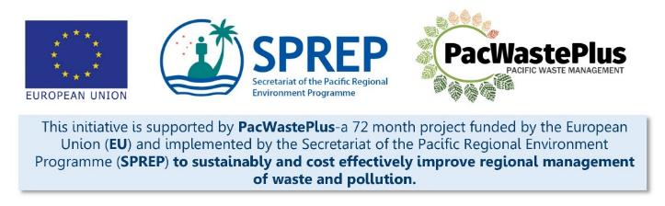
Sustainable Financing for Waste Management: Design It Yourself Workbook

Step 2 - Pre-Feasibility Study
What Involved to Complete Step  To confirm the high-level viability of implementing an ARFD system that meets the identified needs and goals, it is recommended to complete a Pre-feasibility Assessment.  This step will assist to gather data to:  - Identify current in-country management of potentially recyclable material  - Consider options for how a scheme may operate and flow and identify key players  - Consider options for scheme components – i.e.,:  - In-Country Materials Processing/Transfer (identifying existing facilities and equipment for processing/transfer recyclable materials)  - Collection Depots (component of the scheme most people will interact with)  - Scheme Financial Management (component most important to scheme partners such as Private Sector importers)  - Scheme Model (“deposit” or “refund” model)  - Identify key stakeholders  - Identify the role of the government  - Identify the possible scheme ‘owner’ or partnership who will lead the design and implementation of the ARFD  - Identify where a scheme may fit in legislation  This step provides assists to gather data to determine what is important for key decisions for scheme design. It presents “pros” and “cons” for consideration when comparing options to make an informed decision. | Information / Consultation Recommended to Complete Step  - Findings from a recent Waste Audit or complete a Waste Audit using a consistent methodology  - Case-study review – schemes currently in operation globally and existing legislation for PIC schemes in operation (SPREP / PacWaste Plus can supply legislation/regulations)  - Information from market assessments and research – opportunities for export / in-country recycling  - Information from customs – data on items imported  - Information from in-country bottlers / manufactures etc – quantity of materials produced  - Information from recyclers and exporters – current recycling rates, information on materials processing, data on items exported  - Information from recyclers and businesses undertaking recycling / reuse initiatives – current recycling rates, materials processing  - Information from certified export markets (companies who will receive and recycle recyclable material) to understand any restrictions on material quality, quantity, handling, etc  - Information from Treasury / Finance – options for scheme financial management and establishment of dedicated fund  - Information from Justice / AG Office – existing waste, finance and customs legislation | Resources Available  SPREP / PRIS /World Bank / UNEP Waste Audit Methodology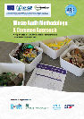  Reloop Review of Global Schemes  PacWaste Plus Recycle Market Study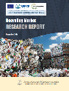 | PacWaste Plus Small-Scale Technology for Waste Management  PacWaste Plus Guide for Investigative Questioning  Legislation for FSM, Kiribati, Palau, RMI, Tuvalu, NSW, Queensland (request from SPREP / PacWaste Plus)
- Further Information on Current Recyclables Management | From an operational (recycling) sense, ARFD schemes have a good chance of being feasible if:  - Items are imported and currently not recycled/exported or only at low quantities  - Equipment exists or can be obtained to manage expected throughput  - An in-country or offshore recycling market is available
To assist in the consideration those questions, gather information to complete the table to identify what companies are involved and equipment in operation, and opportunities for improved management and recycling of those items.
Item | Volume of material imported or manufactured in country (annually) | Material currently collected by in-country recycler(s) / transfer facility(ies)? | If yes = item collected by in-country recyclers / transfer facilities |  |  |  |  |  | If no – item currently not collected by in-country recyclers / transfer facilities
 |  |  | How collected / company(ies) involved | What activities undertaken  Circle activity(ies) and provide detail / volumes etc | Equipment in operation | Percentage recycled – (import / export+ recycled)* | Typical expenses to export 1x 20” sea container | Typical revenue earned – export 1x 20” sea container | What recycling opportunities exist - export or in-country***
PET bottles (plastic) |  | Y / N |  | Exported / Recycled in-country / Stockpiled / Other  Volumes:  Details:
Aluminium cans |  | Y / N |  | Exported / Recycled in-country / Stockpiled / Other  Volumes:  Details:
Glass bottles |  | Y / N |  | Exported / Recycled in-country / Stockpiled / Other  Volumes:  Details:
Other containers – HDPE, LPB, tin food cans |  | Y / N |  | Exported / Recycled in-country / Stockpiled / Other  Volumes:  Details:
Vehicles |  | Y / N |  | Exported / Recycled in-country / Stockpiled / Other  Volumes:  Details:
Heavy Equipment |  | Y / N |  | Exported / Recycled in-country / Stockpiled / Other  Volumes:  Details:
Whiteware |  | Y / N |  | Exported / Recycled in-country / Stockpiled / Other  Volumes:  Details:
Electronics |  | Y / N |  | Exported / Recycled in-country / Stockpiled / Other  Volumes:  Details:
Tyres |  | Y / N |  | Exported / Recycled in-country / Stockpiled / Other  Volumes:  Details:
Batteries |  | Y / N |  | Exported / Recycled in-country / Stockpiled / Other  Volumes:  Details:
Solar panels |  | Y / N |  | Exported / Recycled in-country / Stockpiled / Other  Volumes:  Details:
Used Oil |  | Y / N |  | Exported / Recycled in-country / Stockpiled / Other  Volumes:  Details:
Other** |  | Y / N |  | Exported / Recycled in-country / Stockpiled / Other  Volumes:  Details:
Other** |  | Y / N |  | Exported / Recycled in-country / Stockpiled / Other  Volumes:  Details:
.
* If there is a current effective in-country recycling/transfer industry, it is recommended to consider how and whether this should be included in a scheme. More details in Step 5 – Feasibility Study
** “Other” may include new items currently being imported that are expected to become waste items once reached end-or-life (e.g., solar panels, etc)
*** the PacWastePlus Recycling Market Study https://pacwasteplus.org/resources/recycling-market-research-report/ can help find this information. The report provides information on potential off-shore process / market destinations for e-waste, plastics, aluminium cans, whiteware, vehicles, used oil, batteries, and tyres (and information on material quality and handling requirements which we will further investigate in Step 5). Extracts for e-waste are provided below as an example – more information contained in the report:
Summary of e-waste Export Destinations:
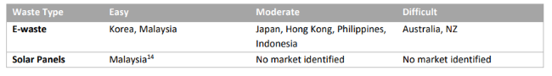
POSSIBLE Export Markets*:
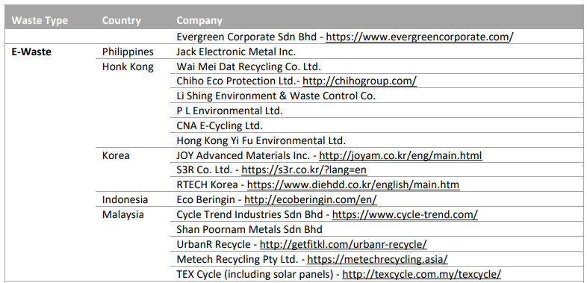
* Note: PacWaste Plus are not promoting these particular recyclers – they have not been verified and are provided only to illustrate potential opportunities for export of potentially recoverable materials. These companies may provide a starting point for who to contact when seeking to understand export options.
Analysis
The above findings help to illustrate the current situation for in-country collection and materials management. Circle items that have a low recycling rate, consider how an ARFD may provide for the collection and recycling/export of these items.
More information will be collected in Step 5 to further identify options for management of these recyclable items

- How a scheme may operate and flow | Using the information gathered above, illustrate, at a high-level, how a scheme may operate and flow . This will help identify the key players in a scheme and how they link together, and identify the “behind the scenes mechanics” that are needed to provide for an effective and sustainable scheme.  Drag the images and create a flow chart to illustrate the movement of items and flow of deposit/fee. This can be just a rough illustration for now, it can be refined as further investigation/analysis is complete.
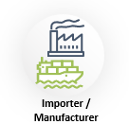
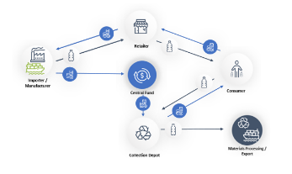
Example:

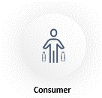

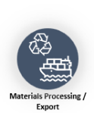

Palau Scheme |  | New South Wales Scheme
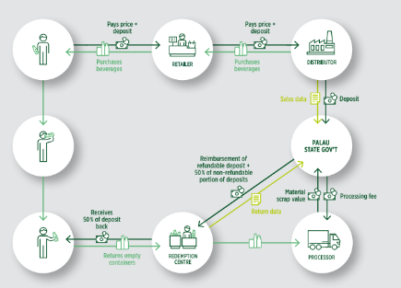 |  | 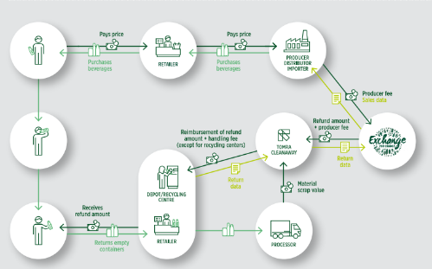
See more illustrations and review information on schemes in operation around the world at the RELOOP Global Deposit Book

- Options for Key Scheme Components | During this pre-feasibility stage, it is recommended to consider four key components of an ARFD scheme – (i) options for In-Country Materials Processing/Transfer, (ii) Collection Depots, (iii) Scheme Financial Management, and (iv) the Scheme Model.  By understanding the current situation and considering options for scheme collection infrastructure and financial systems at an early stage, provides the ability to see how the scheme may operate and enable the identification of key infrastructure required, and agencies that necessary to assist in scheme planning and design.  Note: these activities are intended as a pre-feasibility step and not to be used as final answers. These early analysis of options may need to be reconsidered after the feasibility study is complete and consultation undertaken.
- Options for In-Country Materials Processing/Transfer | Continuing from the table in Step 2.1 above, it is recommended to further analyse any existing recycling or materials processing activities or operations to understand:  - Who are the current recyclers/transfer facilities  - What items are they collecting  - What equipment do they have in operation  Understanding the current situation will facilitate the design an ARFD which addresses limitations, supports existing businesses, and provides solutions for material not currently being recovered.  Complete the table below to identify existing recyclers/transfer facilities and their current operations.  Current businesses / agencies collecting potential ARFD items What items do they currently collect and process What is the size of the facility? what equipment is in operation? Current throughput Could this facility have potential to be a partner in the ARFD? What systems / contracts may be necessary?  Example: ABC Scrap Metal Recyclers EOL Vehicles, copper, iron Aluminium Yard approx. 1 acre Plasma cutter Large scale scrap metal baler 2 x 20” sea containers per month – ferrous metal 1 x 20” sea container per month – non-ferrous metal Yes - By contract as a service provider to process metal items
- Options for Collection Depots | Collection Depots are the component of a scheme that the most people will interact with – they are what will come to the mind of communities when they think of a scheme. The more effective the Collection Depot, the more effective the scheme.  At the pre-feasibility stage it is recommended to start considering what style of Collection Depots may work. More analysis will follow in Steps 5 and 8, in this Step it is recommended to consider the local context and, at a high level, start to understand what may be important for Collection Depots to achieve to enable an effective ARFD, and the pros and cons of different collection types.  Around the world, typical options for styles of Collection Depots include:  - Central depot  - Community depots  - Store Buy-Back / Return-to-Retail  - Mobile return facilities  - Automated depots / Reverse Vending Machines (RVMs)  - Informal Return Facilities  The below section provides some further details on these Collection Depot styles and lists some pros and cons with each. Data gathered to complete the following table will assist the consideration of what may be important in the design of Collection Depots.  Noting these are just preliminary plans which will be discussed, confirmed, and amended during the feasibility study and/or during community consultation.  Keep in mind what the scheme is being designed to achieve (Step 1)
Geographical Context
Complete the table to assess population spread and geographical context.
Population of country
How many inhabited islands
How many provinces
Population of main island or capital
How many towns/cities of more than 30,000 people
How many communities with more than 1,000 people
What is the community structure
Considering the island / community furthest from the main town/capital, how does this community get deliveries of food and household items – what are the infrastructure and existing transport networks?
Considering shipping and land transport - what does it cost for delivery of a pallet of goods to this community?
Are there any local “taboo’s” or customs that may provide a barrier for households to return “waste” materials (and receive a refund)?
Are there any existing village structures or schemes (i.e., youth groups, community loan schemes, etc ) that may provide an opportunity for households to return “waste” materials (and receive a refund)?

The following illustration highlights scheme return rates from across global ARFD scheme comparing population per return facility (x axis) against deposit rates in USD (y axis). This graph illustrates that to achieve a recycling rate of around 80% (regardless of the level of Deposit), one Collection Depot is recommended per 2,500 people, and the more Collection Depots (and the higher the Deposit component) the higher the recycling return rate will be.

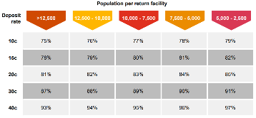

 | What factors may be important for Collection Depots to enable an effective ARFD. Options are provided to the right – consider each and answer yes (if important) or no (if not). Add comments or further important factors in the “other” category.  These results may improve understanding of the best Collection Depots style or styles. Different material types (beverage containers v bulky waste) and different communities (capital island v outer provinces) may have different requirements for Collection Depots. Note thoughts / ideas for further analysis in later steps. | Consider what Collection Depot to achieve | Y/N | Comments
 |  | Equal access to all communities across the country
 |  | Inclusive access and operating hours – people of all ability levels and working hours can access
 |  | Establish meaningful employment opportunities
 |  | Link in with existing infrastructure
 |  | Community owned and operated
 |  | High consideration for managing fraudulent activities
 |  | Appropriate to local setting and community
 |  | Schemes provide a “product stewardship” approach (if a retailer sells an item, they are required to "buy” it back)
 |  | Other:
 |  | Other:
 | Details on different Collection Depots types are provided below. Consider previous answers, and the pros and cons provided, and provide comments on each type – make note of what style(s) may be appropriate.

 | Information | Pros | Cons | Write additional factors or comments – would this option work for all communities? If not, what would be needed to make it work?
 | Large standalone depot or as part of existing business (i.e., scrap metal yard) specifically catering to the collection of scheme materials. Depot centrally located and cater for a wide population. Can be operated by the Scheme Manager or a Private Sector agency via contract. | Depots registered with the Scheme Manager to provide a service that maintains scheme integrity, minimises fraudulent activities and provides customers with a consistent service.  Creation of meaningful employment opportunities  Centralising depot operation will requires less inspection and auditing  May be co-located with existing recycling organisation | May be large facilities and expensive to establish  May not be accessible for remote/small communities
 | Small standalone depot or as part of existing agency (i.e., NGO, community centre, etc) catering to the collection of smaller scheme materials (beverage containers, small e-waste). Depot located in communities to cater for local population. Usually operated by a Private Sector agency or NGO via contract. | Depots registered with the Scheme Manager to provide a service that maintains scheme integrity, minimises fraudulent activities and provides customers with a consistent service.  Creation of meaningful employment opportunities  May be co-located with existing NGO, community centre, etc | Many facilities may be expensive to establish  Requires identification of labour and training  Requires inspection and auditing to ensure each depot provide agreed consistent service  Limited to collection of smaller items
 | Retail shops accept and collect the eligible items that are sold on premises – i.e., if selling beverages, will “buy-back” the empty PET and aluminium containers, if selling whiteware, will “buy-back” bulky e-waste. Operated by existing store workers. | Link with large network of facilities already established throughout PNG and who have transport / logistics in place  Convenient for the consumer, if they are able to purchase item then can access same location to claim refund  Creates Product Stewardship responsibility for retailers  Provided additional income source for retailer | Can be difficult to regulate  Priority of business may be other existing operations and not willing to provide MRF service  Not all retailers will have space, storage, security for effective MRF operation  Requires inspection and auditing to minimise fraud
 | Mobile collection to service remote or regional areas where permanent depots are not available. Facilities are transportable and able to be located at area for a set period of time – either for a few hours or a few days. Can be operated by the Scheme Manager or a Private Sector agency via contract. | Ability to reach rural communities where it may not be economic to establish fixed depot or does not have existing retail stores  Convenient for the consumer if scheduled for mobile depot known in advance  Mobile depot may be operated by Scheme Manager which may minimise fraudulent activities | Can be difficult to regulate  No fixed location – limited convenience for consumer if schedule not agreed and maintained  Schedule may be interrupted due to weather and other events  Limited to collection of smaller items
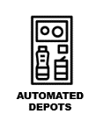 | Automated depots that utilise technology to identify, sort, collect and process used beverage containers instead of staff. Usually located at retail shops or other central area. | Operating may be cheaper due to being unmanned with less labour costs  May be appropriate for city areas to provide convenience and accessibility for users  Accurate counting and processing of scheme material  May minimise fraudulent activities | Limited social connection  Requires consistent power and internet so may be limited application in rural and/or remote areas  Potential increased capital cost - requires technology to count and sort material  Require regular servicing and maintenance by trained technicians  May be seen as target for crime  Limited to collection of beverage containers
 | Collection service established separate from main scheme where entrepreneur or community group established to collect eligible scheme material and deliver it themselves to a formal depot. Informal depots may be mobile or fixed, and may be run by community groups, social groups, and/or private individuals. | Creation of employment/income opportunities to marginalised groups  Can be operated alongside formal collection depots  Option provided for individuals to donate deposit to local group  Provides for social connection and interaction  May provide link with existing litter pickers | May be difficult to regulate, less control by scheme operator  Service offered may be inconsistent across PNG  Limited transparency of collected material, may be higher potential for miscalculation of fraud
 | Detail other potential Depot styles to suit local context

- Scheme Financial Management | During the design of PICs schemes, transparent and trustworthy financial management is regularly raised a key component for scheme partners (i.e., Private Sector recyclers and importers). Evidence shows schemes are more effective and sustainable if there is a dedicated, secure, and transparent fund. Without effective scheme financial management, scheme stakeholders may not support or participate in a scheme.  As such a key component, it is recommended at this pre-feasibility stage to consider options for financial management of the scheme and operation of the fund. Understanding theses will enable the identification of:  - appropriate partner agencies  - controls that may be needed to implement a financially trustworthy and effective scheme
 | Consider what is needed to ensure the fund is secure and appropriately administered to achieve desired goals for communities and the environment, and is financially fair and transparent.  Options are provided to the right – consider each and answer yes (if important) or no (if not). Add comments or further factors in the “other” category.  These results may help determine the financial management structure of the scheme. | Consider what important for scheme financial management | Y/N | Comments
 |  | Transparent
 |  | Secure
 |  | Auditable
 |  | Trusted by importers
 |  | Trusted by recyclers
 |  | Trusted by community
 |  | Minimise fraud
 |  | Refunds are calculated and issued
 |  | Accurate movement of money
 |  | Financial transparency
 |  | Other:
 |  | Other:
 | Options for agency/partnership to hold and administer the fund are detailed below. Consider previous answers and the pros and cons provided, and note comments on suitability of each type.

Information | Central “ringfenced” Fund held and administered by government (i.e., Ministry of Finance) | Government budget held and administered by Ministry of Environment | Government budget held and administered by another government office (i.e., Customs, Infrastructure, or PMU) | Secured private account held and administered by Managing Agency | Secured private account held and administered by Private Sector agency (i.e., accounting firm) | Detail other options to ensure the fund is secure and appropriately administered
Pros | Fund “ringfenced” by regulation, providing control that revenue will only be spent on approved used to enable operation of the scheme.  May reduce fraudulent activities.  Ministry of Finance have existing systems and expertise to manage finances and undertake required auditing / reporting.  Fund can be audited and controlled through existing government processes.  Consultation required with Ministry of Finance to ensure capacity to be scheme partner. | Fund can be audited and controlled through existing government processes.  Environment is likely scheme owner and can dedicate admin support to manage scheme finances  Potential reduction in double handling of scheme finances – i.e., Environment manages payments of ARFD expenses when required. | Fund can be audited and controlled through existing government processes.  May reduce fraudulent activities.  Consultation required with other government office to ensure capacity to be scheme partner. | Contract for Managing Agency can specify strict controls for fund auditing and control.  May reduce fraudulent activities due to contractual controls.  Reduced burden to Ministry of Finance and government offices.  Managing Agency can ensure admin support, systems, and expertise to manage finances and undertake required auditing / reporting. | Contract can specify strict controls for fund auditing and control.  May reduce fraudulent activities.  Reduced burden to Ministry of Finance and government offices.  Private Sector can ensure admin support, systems, and expertise to manage finances and undertake required auditing / reporting.
Cons | Ministry of Finance may not have capacity or desire to be a scheme partner, consultation required.  Potential double handling of scheme finances – i.e., Environment submit claim to Finance for invoice to be paid.  Private Sector may not trust government processes and could be concerned revenue may be misallocated. | Fund may not be “ringfenced” by regulation, not providing a control for revenue to only be spent on approved used.  May enable fraudulent activities if same Ministry management scheme also manages fund.  Ministry of Environment may not have existing systems and expertise to manage finances and undertake required auditing / reporting.  Private Sector may not trust government processes and could be concerned revenue may be misallocated. | Fund may not be “ringfenced” by regulation, not providing a control for revenue to only be spent on approved used.  Other government office may not have capacity or desire to be a scheme partner, consultation required.  Potential double handling of scheme finances – i.e., Environment submit claim for invoice to be paid.  Private Sector may not trust government processes and could be concerned revenue may be misallocated. | Fund may not be audited and controlled through government processes.  Government may lose control of scheme finances.  Drafting contract for Managing Agency requires detail and attention. | Fund may not be audited and controlled through government processes.  Government may lose control of scheme finances.  Drafting contract requires detail and attention.
Write additional factors or suggestions

- Scheme Model (when the ARFD collected) | The model for the ARFD (i.e., a “deposit” model or “refund” model) and determining when the ARFD will be collected is recommended to be considered at the pre-feasibility stage to ensure options for the financial flow and management of the scheme and appropriate partner agencies.  Answer the following questions to understand whether a “deposit” model or “refund” model may be the most suitable for scheme implementation:
 | Questions | Answers
 | Circle or highlight whether potential ARFD items are imported or manufactured in-country:
 | Beverages | Mostly imported | Mostly manufactured in country | About even – both imported and manufactured in country
 | Bulky items | Mostly imported | Mostly manufactured in country | About even – both imported and manufactured in country
 | Is the department of Customs a likely partner in the ARFD (i.e., to collect ARFD at the border)? | Yes – likely | No – unlikely | Unknown – consultation needed
 | Will Unredeemed Deposits likely to be used for operating the scheme | Yes | No | Unknown
 | Are the Private Sector importers or manufactures likely to want to operate parts of the scheme – operate Collection Depots etc | Yes – likely | No – unlikely | Unknown – consultation needed
 | Are the Private Sector importers or manufactures likely to prefer to pay the ARFD: | At border – i.e., can’t collect from wharf until ARFD paid | Invoiced on a monthly basis | Unknown – consultation needed
 | Are Private Sector retailers of ARFD items likely to have good record keeping? | Yes | No | Unknown
 | Will ARFD items likely to be collected and processed by: | Government or other agency expert in collection and recovery of materials | Private Sector importers or manufactures producing the items to be involved in their collection and recycling | Unknown
 |  | If more answers in this column:  Deposit model may be appropriate | If more answers in this column:  Refund model may be appropriate | If more answers in this column:  Further consultation is required

Options for the scheme model and when the ARFD is collected are provided below. Consider previous answers and the pros and cons provided, and note comments on each type.
 | 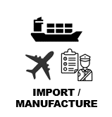
Information | Deposit and Fee collected from producers (importers / manufactures) in advanced (i.e., upon import, usually by Customs, or manufacture, usually by Scheme Manager). Deposit and Fee collected on all eligible items, regardless if item returned to a Collection Depot for recycling. This is model is considered a “Deposit Model” | Deposit and Fee collected from producers (retailers) in advanced (but after first sale). Deposit and Fee ususally collected by Scheme Manager through monthly invoice. Deposit and Fee collected on all eligible items, regardless if item returned to a Collection Depot for recycling. This is model is considered a “Deposit Model”. | Deposit and Fee collected from producers after items have been returned to a Collection Depot for recycling. Deposit and Fee ususally collected by Scheme Manager through monthly invoice. This is model is considered a “Refund Model”. | Detail other options for scheme model
Where in operation | All Pacific Schemes |  | All Australian Schemes
Pros | Most items can easily be captured through central point (customs).  Customs have existing systems and expertise to collect Deposit and Fees.  Reduced ability for importers to not participate in the scheme as items are unable to leave the wharf until ARFD is paid.  Deposits that are “unredeemed” can be reinvested back into the scheme (for approved uses).  Reduced administrative burden for Scheme Managers as invoicing may only be required for ARFD items produced in country | Reduced burden for Customs if they do not have capacity to be partner.  Private Sector importers may be more favourable towards Deposit and Fee collected monthly, as they will not be faced with the ARFD “upfront”.  Deposits that are “unredeemed” can be reinvested back into the scheme (for approved uses). | Reduced burden for Customs if they do not have capacity to be partner.  Private Sector importers may be more favourable as they are only responsible for payment of Deposit and Fee on items returned for recycling.  Provides extra incentive for Scheme Manager to provide facilities to collect ARFD items from communities as they will only receive the Fee component on items returned.
Cons | May not provide an incentive for Scheme Manager to provide extra facilities etc to collect ARFD items from communities as scheme will receive the Fee component on items regardless if they are returned or not. This incentive can be managed by setting return targets etc via contract.  Management of any importers with ability to by-pass paying import duty and customs.  Customs may not have capacity or desire to be a scheme partner, consultation required.  Customs systems may require upgrading to enable the identification and capture of items.  Private Sector importers may initially be against the Deposit and Fee collected at the border, feeling like the ARFD is a “tax” applied on their products, and up unfavourable of the “upfront” obligation which may have a temporary effect on their cash flow. | May not provide an incentive for Scheme Manager to provide extra facilities etc to collect ARFD items from communities as scheme will receive the Fee component on items regardless if they are returned or not. This incentive can be managed by setting return targets etc via contract.  Administrative burden for Scheme Managers as invoicing and follow-up will be required for all ARFD importers.  Ability for importers to choose not pay ARFD requiring enforcement by Scheme Manager.  Requires good data collection and management to record items sold and invoice accurately | There will be no “unredeemed” Deposits to be reinvested back into the scheme (for approved uses).  Accurate calculation of the Fee component required to ensure it covers the true cost of recycling scheme item as there will be no “unredeemed” Deposits to assist in scheme operation.  Administrative burden for Scheme Managers as invoicing and follow-up will be required for all ARFD importers.  Ability for importers to choose not pay ARFD requiring enforcement by Scheme Manager.  Requires good data collection and management to record items returned and invoice importers, retailers, and manufacturers accurately.
Write additional factors or suggestions

- Identify key stakeholders | It is recommended to consider and provide some high-level comments on each of the key players, i.e., who they are and what they may find important when participating in an ARFD.  By identifying these stakeholders and considering what may be important to them at this pre-feasibility stage will assist to have meaningful conversations with a Working Group and commence designing a scheme.  Noting these are preliminary comments which will be discussed, confirmed, and amended during the feasibility study and/or during community consultation.

Their possible role in an ARFD scheme (consider the question) | Who are the main importers of potential ARFD items?  Who are the in-country manufactures (i.e., breweries / water bottlers)?  How would importers and manufactures be involved in the ARFD?  What may be important for importers and manufactures to participate in a scheme? | Who are main retailers of potential ARFD items?  How would retailers be involved in the ARFD?  What may be important for retailers to participate in a scheme? | How would consumers be involved in the ARFD?  What may be important to consumers to participate in a scheme? | Who are the current recyclers/transfer facilities of potential ARFD items?  How would recyclers/transfer facilities be involved in the ARFD?  What may be important for recyclers/transfer facilities to participate or partner in a scheme? | How to provide equal access to the ARFD for all communities? | How would Finance be involved in the ARFD?  What may be important for Finance to participate or partner in a scheme? | How would Customs be involved in the ARFD?  What may be important for Customs to participate or partner in a scheme? | What other agencies be involved in the ARFD?  What may be important for those agencies to participate or partner in a scheme?
Write additional factors or comments

- Role of Government | It is recommended to consider and provide comments on what possible role the government will have in a possible ARFD scheme.  Consider the options below – provide thoughts on whether the government is placed to administer that role.
 |  |  |  |  | Role of the Government? | What Government agency may be best placed to undertake that activity |  | Provide additional comments or details
 | Manage system – operate Collection Depots, operate Materials Processing Facility, day to day operations |  | 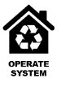 |  | Yes / No
 | Manage system via contract – oversee contracts for Collection Depots, In-Country Materials Processing/Transfer Facility, logistics, etc |  |  |  | Yes / No
 | Administer Scheme Fund – Manage scheme finances |  | 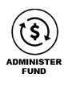 |  | Yes / No
 | Oversee/ govern system at a high level – inspect / monitor operation of Collection Depots, In-Country Materials Processing/Transfer Facility, etc |  | 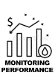 |  | Yes / No
 | Other
- Possible ‘owner’ of the system | After considering the role of government, it is recommended to consider the department (or departments via a partnership) who may be the “owner” of the scheme. This scheme owner will not necessarily be the Scheme Manager or Governance Body (which are considered in Step 8) but by confirming a scheme owner at this Pre-Feasibility stage will assign a clear leadership and ownership role to one department.  During scheme design, the scheme owner would be responsible for activities such as:  - Clarifying under which department the scheme legislation / regulation may sit  - Identifying and being key liaison with the political champion (Step 3)  - Leading the political approval process (Step 12)  - Leading the Working Group (Step 4)  Further considerations of Scheme Management and Governance will come later in this process, but for now consider the options and note ideas to determine the scheme owner responsible for leading this design process.
Consider the options provided for the scheme owner and assign the likely scheme owner and scheme partners by dragging the icons into one of the three boxes |  | 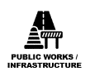 |  | Likely scheme owner/partners (drag and drop): |  |  | Comments – why selected? What ownership or partnership role will agency have?
 |  |  |  | Likely scheme owner (or owners if a partnership approach is preferred) – recommend no more than three
 |  |  |  | Likely scheme partners
 |  |  |  | Not involved

- Identify where a scheme may fit in legislation |  | It is recommended to consider and provide some high-level comments on where and how a scheme may fit in existing government legislation, and identifying possible ‘parent’ legislation (or need to develop one) for the following aspects:  - scheme operations (collection of the ARFD and management of the scheme)  - scheme finances (establishment and administration of the dedicated fund)  Options:  - Develop new ARFD Regulation under an existing Act (amendments may be required)  - Develop new Waste Management Act and an ARFD Regulation  - Develop new standalone ARFD Act and an ARFD Regulation  To understand and assess options, it is recommended to undertake an assessment on existing legislation by completing the following tables (recommended to be completed in partnership with the AG / Justice team).  If AG / Justice require a quick scheme overview, the following comments may be useful [tailored to local context with information/comments gathered above – or provide completed Pre-Feasibility Assessment]:  - Seeking to implement an ARFD scheme to improve rates of recycling across the country  - Scheme will include:  - Collection of a Fee and Deposit on potentially recyclable items  - Fee and Deposit held in a dedicated fund, controlled by Regulation and used only for purpose of scheme  - Scheme infrastructure will include Collection Depots and Materials Processing – operations controlled by Regulation  - Deposit component returned to consumers once items dropped off to a Collection Depot  - Fee component used by authorised Scheme Manager to undertake the collection, transport, processing, and export/recycling of recoverable materials  - Seek to understand if/how existing legislative environment can provide for:  - collection of Fee/Deposit (Levy) on certain items  - establishment / administration of dedicated fund  - developing a Regulation to govern a waste management activity
With the AG / Justice team, gather existing legislation that may be relevant to for an ARFD (Waste Management, Environment, Customs, Finance, other) and list their names and provide a brief analysis of how these acts provide for waste management / recycling activities
 | Exact Name | Main Purpose / Activities
e.g., Waste Management | Solid Waste Management Act 2017
Waste Management
Environment
Infrastructure
Customs
Finance
Other
Other

To understand existing legislation that is able to be used to empower the proposed scheme, it is recommended to undertake an assessment of relevant clauses / key words by completing the following table (recommended to be completed in partnership with the AG / Justice team).
Are there existing clauses to… |  | If yes, include the exact wording under the reluctant act / act(s) or regulation
 |  | Waste Management Act | Environment Act | Infrastructure Act | Customs Act | Finance Act | Other
enable collection of levy on items causing potential environmental harm | Y/N
provide for establishing a regulation to regulate waste activities | Y/N
give power to establish a dedicated fund for waste management purposes | Y/N

With an AG / Justice Officer, consider the options for where and how a scheme may fit in existing government legislation, and note pros and cons for each option
Provide comments to identify possible ‘parent’ legislation
 | Develop new ARFD Regulation under an existing Act |  | Develop new Waste Management Act and an ARFD Regulation | Develop new standalone ARFD Act and an ARFD Regulation | Other
Example Comments / Pros and cons | Environment Act 2015 is in place, developing regulation is faster than drafting a new dedicated Act.  Act provides for a Climate Change and Environment Protection Fund which can be adapted to provide for ARFD.  Without clear “ring fencing”, ARFD fees could be used for other purposes if consolidated into a single Climate Change and Environment Protection Fund. |  | Keeps waste management and ARFD separate from other environmental priorities.  Can give specific power to implement an ARFD scheme.  Can provide specific details for management of other matters relating to solid waste management and recycling.  Could take longer to implement a new Act and Regulation compared to using provisions in the Environment Act.  Reliance on key stakeholders to prioritise completion of Act. | Keeps ARFD operation and fund separate from other legislation.  Potentially less time required to draft and pass into law than a comprehensive waste management Act.  Could take longer to implementation a new Act and Regulations compared using provisions in the existing Environment Act.  Depends on key stakeholders to stay attentive and prioritise development of Act.  Could distract from the development of a wider ranging waste management Act.
Provide comments / list pros and cons relevant to existing legislation
Provide additional factors or suggestions to identify possible ‘parent’ legislation
With the AG / Justice team, confirm possible approach for where the scheme may fit in legislation:
 | Name (existing or proposed) | Detail empowering clause(s) if needed | Does Legislation / Regulation Exist?  Yes / No
Act:
Regulation:
Dedicated Scheme Fund:

Notes for Follow-up / Further Research / Discussions:

