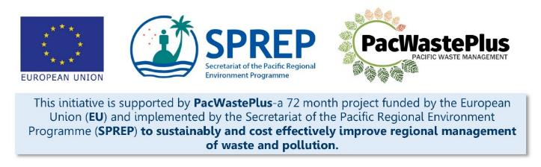
Sustainable Financing for Waste Management: Design It Yourself Workbook

Step 19 - Scheme Implementation
What Involved to Complete Step  The scheme has been designed in collaboration with community and stakeholders, legislation is approved, and facilities are in place. Now we are ready for scheme implementation – Congratulations!  Activities in system implementation may include:  - Choosing a date on which the scheme takes effect or ‘goes live’ and clearly communicating the date to scheme participants  - Considering a ‘soft start’ or pilot approach to implementation, allowing for testing of infrastructure, including for example testing Collection Depots accessibility by persons with reduced mobility and vision  - Ensuring data collection templates and requirements are in place and training undertaken with scheme partners  - Commence recycling activities and process and export items to markets identified in Step 2 and 5  - Establish a feedback and complaints mechanism |  | Information / Consultation Recommended to Complete Step  - Findings from the feasibility study and detailed scheme design  - Findings / feedback from political and stakeholder consultation (with communities. Government agencies, and private sector)  - Results from policy and legislative approval | Resources Available  PacWaste Plus Recycle Market Study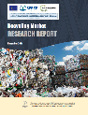 | PacWaste Plus Guide for Considering GEDSI in ARFD Design  Specific data collection templates (request SPREP / PacWaste Plus assistance)
- Data / Record Keeping Procedures | Ensure the record keeping for collection of data on users of the scheme according to business /private / gender / level of mobility. This information provides the foundation for annual, independent audits to understand users of the scheme and who is missing out.  Templates provided below in Step 20 or contact SPREP / PacWaste Plus who can assist to develop scheme specific data collection templates
- Undertake Scheme Activities | Commence recycling activities and processing and export items to markets identified in Step 2 and 5  POSSIBLE Export Markets for e-waste *:  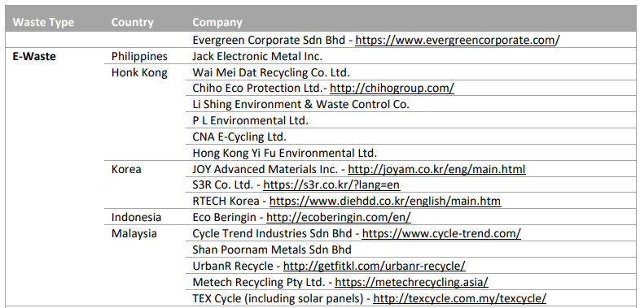  * Note: PacWaste Plus are not promoting these particular recyclers – they have not been verified and are provided only to illustrate potential opportunities for export of potentially recoverable materials. These companies may provide a starting point for who to contact when seeking to understand export options.
- Feedback and Complaints Mechanism | Establish a feedback and complaints mechanism, accessible to all communities and users (i.e., of different languages, different levels of literacy or ability, and potentially providing for use of points in community structures who can act as facilitators to ensure communities are able to provide feedback/complaints), to allow scheme participants to provide feedback and complaints on the scheme.  Options for establishing a complaints mechanism may include:  - online platform for providing feedback or lodging complaints could be created, such as through a facebook page.  - traditional methods such as voicing concerns through community leaders and community governance processes such as community/village meetings  - central online platform
Notes for Follow-up / Further Research / Discussions:

