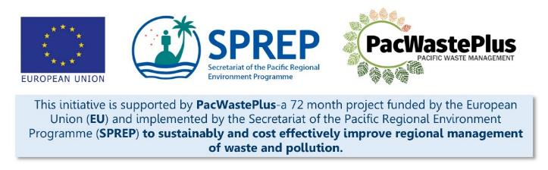
Sustainable Financing for Waste Management: Design It Yourself Workbook

Step 17 – Legacy Waste Management
What Involved to Complete Step  ‘Legacy waste items’ (items that entered the country before an ARFD took effect, so therefore had no deposit paid on them). Legacy waste, if unmanaged, can overwhelm an ARFD system at scheme commencement.  This Step will assist to implement the legacy waste management option selected and consulted on in previous steps. |  | Information / Consultation Recommended to Complete Step  - Findings from the feasibility study and detailed scheme design  - Results from consultation
- Manage Legacy Waste | In Section 8.9, an appropriate system for managing legacy waste was identified based on the findings in Step 5.6. Options included:  Use the following table to complete managing legacy waste using the identified method  Selected Legacy Waste Management System Who Responsible Key Activities Expected Date for Completion
Notes for Follow-up / Further Research / Discussions:

