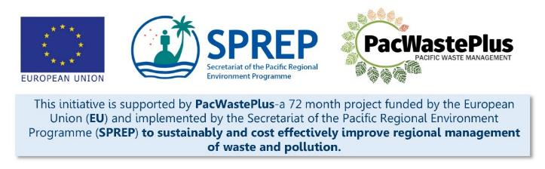
Sustainable Financing for Waste Management: Design It Yourself Workbook

Step 16 - Training
What Involved to Complete Step  Agencies identified throughout this design process to partner or participate in scheme operation (e.g., equipment operators, scheme manager, customs officials, finance officers, compliance officers, etc) will require training to ensure staff have knowledge and capacity to undertake the necessary tasks.  This step will assist to determine required training and develop plan for training to be undertaken. In this step, it is recommended is consider all possible training needs for the successful enactment of the scheme – examples of training may include:  - Training on implementation of scheme SOPs (developed above) to guide operation of components of the scheme  - Training for Finance officials to up-skilling in new accounting software  - Training for equipment operators at recycling facilities in health and safety  This step is recommended draw upon information gathered through previous steps (primarily in Steps 13 and 15). |  | Information / Consultation Recommended to Complete Step  - Findings from the feasibility study and detailed scheme design  - Findings / feedback from political and stakeholder consultation (with communities. Government agencies, and private sector)  - Information from relevant departments (customs, finance, enforcement, etc) - software, database, SOP requirements
- Develop Identified Systems | Based on findings above, summarise training requirements for enactment of the scheme and identify responsible agencies to develop and undertake the training.
Scheme Requirements (list identified equipment / facilities / software / databases / SOP identified above) | Training Required to Safely and Effectively Operate Identified Software / Databases / SOP?  Y / N | Details of Training Required | Relevant Organisation / Agencies to Receive Training  Identify Number of Staff | Identify Relevant Organisation / Agencies to Develop and Deliver Training | Budget Required | Staff Training to be Funded by Scheme?
e.g., Baler at Materials Processing Facility
Collection Depots

Notes for Follow-up / Further Research / Discussions:

