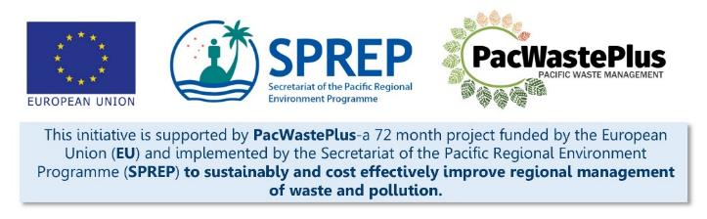
Sustainable Financing for Waste Management: Design It Yourself Workbook

Step 15 - System Creation (Customs / Finance / Contracts)
What Involved to Complete Step  Utilising the design of the system, and the outcomes of the feasibility study and consultation, confirm the systems needed to implement the system.  Depending on scheme design, a scheme is likely to require:  - customs processes to collect ARFD upon imports  - finance system for fund establishment and transparent management and administration  - environmental compliance staff to undertake necessary industry compliance inspections  - contract management for operation of scheme logistics  - systems for compliance and enforcement, monitoring and evaluation, and auditing  This step will assist to determine requirements for system creation and develop plan for establishment. This step is recommended draw upon information gathered through previous steps (primarily through Steps 5, 8, and 13). |  | Information / Consultation Recommended to Complete Step  - Findings from the feasibility study and detailed scheme design  - Findings / feedback from political and stakeholder consultation (with communities. Government agencies, and private sector)  - Information from relevant departments (customs, finance, enforcement, etc) - software, database, SOP requirements | Resources Available  Customs HS tariff classification for ARFD products (request from SPREP / PacWaste Plus)
- Develop Identified Systems | Based on findings above, identify system required for enactment of the scheme and identify responsible agencies to undertake the installation of identified software or develop required SOPs, including requirements for data collection.  Possible Scheme Requirement Systems Required Y / N Responsible Department Systems Required (i.e., software / databases etc) Responsibility for Procurement Timeframe for Installation Document / SOP Required to Guide Operation (list details) Responsibility for Drafting and Approving SOP  Undertake Contract Management  Undertake System Management  Undertake Scheme Governance  Operate Materials Processing Facilities  Operate Collection Depots  Undertake Scheme Logistics  Upgrade Customs System  Operate new customs system  Administer Scheme Funds / undertake Financial system  Operate Accounting software  Undertake Phone application (“app”) Design and Administration  Operate Barcode system  Undertake Website Design and Administration  Undertake Compliance / Enforcement activities  Undertake Criminal investigation  Undertake Auditing  Undertake Reporting  Undertake Promotion and Advertisement  Other  Other  TOTAL
Notes for Follow-up / Further Research / Discussions:

