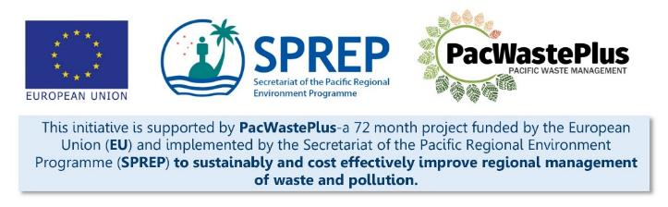
Sustainable Financing for Waste Management: Design It Yourself Workbook

Step 14 - Legal Adoption
What Involved to Complete Step  If consultation (Step 11) and political endorsement (Step 12) has highlighted continued support for the scheme, it may be possible to commence the formal political approval process. This formal adoption would follow normal government processes.  This step will assist to track the steps required to obtain political endorsement for the scheme. |  | Information / Consultation Recommended to Complete Step  - Findings from the feasibility study and detailed scheme design  - Findings / feedback from political and stakeholder consultation (with communities, Government agencies, private sector, etc) | Resources Available  PacWaste Plus Guidance - Example Table of Contents for ARFD Policy and Drafting Instructions
- Guide Political Endorsement | Detail the steps generally required to obtain political endorsement of a new legislation / regulation. If no template is available, the following table may assist identify the key steps and track the template process.  Steps for Political Endorsement Needed? (Y/N) Tentative Dates Actions Outstanding Who Responsible  Working Group Established  Feasibility Study  Policy Paper  Cabinet Submission  Presentation to Cabinet  Pre-consultation paper  Politicians site visit to landfill or recycling facility  1st reading  2nd reading  Consultation  Post-consultation Briefing  3rd reading  Translation  Cabinet Approval  Parliamentary Approval  Other
Notes for Follow-up / Further Research / Discussions:

