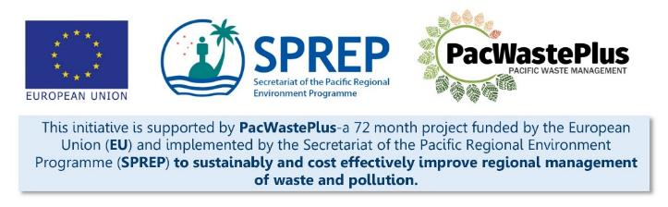
Sustainable Financing for Waste Management: Design It Yourself Workbook

Step 13 - System Needs / Expenses
What Involved to Complete Step  Utilising the design of the system, and the outcomes of the feasibility study and consultation, confirm the infrastructure and equipment needed to implement the system.  This step will assist determine:  - Confirm infrastructure and equipment needed for scheme implementation. These needs will vary depending on the design of the scheme selected. For example, if the scheme is to be government implemented, it may be appropriate to commence procurement activities. If the scheme is to be delivered through a Public Private Partnership, or service contract, it may be appropriate to draft documents and seek approval to release to the market.  - Consider needs of Government Agencies – identifying government staffing requirements and systems required to administer the scheme and commence recruitment/procurement processes (for example, procurement of customs database, monitoring software, etc) |  | Information / Consultation Recommended to Complete Step  - Findings from the feasibility study and detailed scheme design  - Findings / feedback from political and stakeholder consultation (with communities. Government agencies, and private sector)
- Physical Needs of Scheme | This step is recommended to draw upon information gathered through Steps 5, 8, 9 and 11 to identify the physical and operational needs of scheme.  If the proposed scheme will be implemented through a Public Private Partnership, or service contract, it may not be necessary for the government to purchase or procure any system infrastructure directly, but is recommended to summarise the identified infrastructure needs from (primarily) Steps 5 and 8 – prior to drafting and releasing service contracts to the market – to ensure identified infrastructure is reflected in the contracts.  Depending on the model chosen, it is recommended to complete the appropriate section of following table to summarise infrastructure needs for the scheme.  Possible Capex / Physical and Operational Needs Investment Required for Scheme Implementation Provide Details – Type, Size, Number Scheme Identified to Run Though Public Private Partnership, Or Service Contract Scheme Identified to Be Government Implemented  Infrastructure Requirements Specified in Draft Contract? Provide Details Estimated Budget Budget Confirmed? Provide Details Responsibility for Procurement Timeframe for Installation  In-Country Materials Processing/Transfer Facilities  Equipment for In-Country Materials Processing/Transfer Facilities  Collection Depots  Vehicles  Customs System  Accounting software  Phone application (“app”)  Barcode system  Website  Other  Other  TOTAL
- Government Staff and System Needs of Scheme | It is also recommended to identify the needs/expenses of government agencies responsible to implement the scheme. For example extra staff for the Ministry for the Environment, Customs etc to administer the scheme, enforcement staff to support monitoring and auditing etc.  It is recommended to complete the following table to summarise government time and systems needed to administer the scheme.  Government Support Agency Systems Needed to Enact ARFD Provide Details – System Exists? Summarise Infrastructure and/or Software etc Required Estimated Budget Staff / Labour Requirements (hours per week) Recruitment Required? Staff Time to be Funded by Scheme?  Contract Management  Scheme Operation  Customs  Finance / Financial Administration  Compliance / Enforcement  Criminal investigation  Auditing  Reporting  Promotion and Advertisement See Step 18  Website Management  Other  Other  TOTAL
Notes for Follow-up / Further Research / Discussions:

