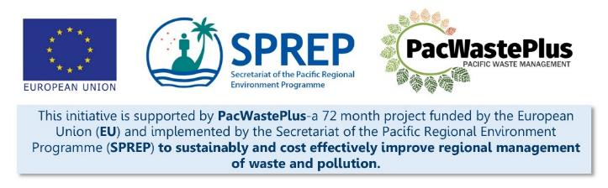
Sustainable Financing for Waste Management: Design It Yourself Workbook

Step 12 - Political Endorsement
What Involved to Complete Step  Following the outcomes of the consultation on the Policy and Legislative Draft, confirm continued political support to introduce the system.  Approval is needed at this point, as past here, funding is required to engage contracts, build infrastructure, purchase equipment, implement training, and commence widespread community and industry engagement and awareness of the soon to be implemented system. |  | Information / Consultation Recommended to Complete Step  - Results from policy approval  - Results from consultation activities | Resources Available  Example policy paper / template (request from SPREP / PacWaste Plus)
- Post-consultation Briefing Note or Cabinet paper | Decision makers may seek a formal post-consultation briefing note that summarises results from the consultation and outlines stakeholders views of the proposal. Use the approved Ministry post-consultation briefing note template if available or develop one to clearly summarise the results and feedback revieved in Step 11.
Notes for Follow-up / Further Research / Discussions:

