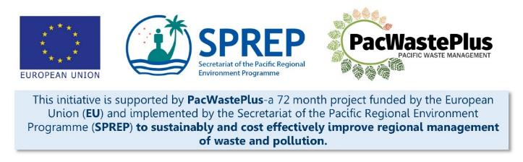
Sustainable Financing for Waste Management: Design It Yourself Workbook

Step 11 - Consultation
What Involved to Complete Step  Once the policy paper is approved and the legislative drafting is underway, it is often a specific requirement for governments to undertake national consultation on the proposal to seek feedback and support.  Note: This step is different from the consultation undertaken at Step 7, which seeks to involve, collaborate, and empower communities and stakeholders on the specific design and operation of the ARFD.  Governments often have set requirements for the national consultation and standard venues and attendees. This Step will assist to prepare for the National Consultation and ensure GEDSI components are considered appropriate. |  | Information / Consultation Recommended to Complete Step  - Findings from the pre-feasibility study and feasibility study  - Findings from legislative assessment  - Approved policy and draft legal drafting | Resources Available  PacWaste Plus Guide for Considering GEDSI in ARFD Design  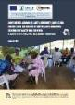  Powerpoint illustrations with speaking notes (request from SPREP / PacWaste Plus) | A Guide to Developing Project Engagement Plans: Stakeholder Education and Awareness 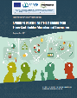  Guide for investigative questioning  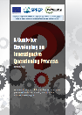
- Stakeholder Engagement Plan | A Project Engagement Plan is recommended to be developed to guide communications and consultation activities. Taking time to plan the engagement process will help build trust with your audience.  The below template may be used as a brainstorming activity to build this plan, identifying the key topics / interests for the stakeholder groups identified above, and summarise engagement techniques and frequency to meaningfully communicate with that group.  Using tools from Step 7, it is recommended to plan stakeholder engagement using the following table
Project Engagement Plan
Stakeholder | Influence / Interest | Key Interest for ARFD | Engagement Techniques  (considering GEDSI factors ) | Frequency | Comments

- Activities to Complete Inclusive Consultation | To conduct inclusive consultation and engage with all members of the community, including those with different needs and requirements, it is recommended to consider including the following activities (or other ones specific to the local country) during the consultation process.  Activities Comments Relevant Y / N Check when Complete  Make contact with a Disabled People’s Organization (DPO). Hold a stakeholder meeting and seek guidance and potential of hiring a person with a disability to accompany future community consultations (keep notes of meeting for future reference – a written agreement or MoU may also be sought for this service support)  Get an updated list of DPO representatives in communities from disability CSO of social affairs ministry. This list will serve as a reference for future project implementations.  Establish community communication with the leaders and existing committees or women’s disability or youth representatives  For communities or village consultation, an initial visit is recommended to inform the chief of the village or leader of the proposal. It may also be appropriate for this meeting to also include the community council, disabled person’s representatives, women’s representative, and youth representatives.  Select a neutral space within the community that all groups can access for meetings and walk through the space with a person with disabilities in advance to check accessibility.  Ensure that the entry to the venue and all meeting room(s) are accessible, including ramps, handrails and doorways that are wide enough for a wheelchair.  Make sure there are accessible toilets close to the meeting room and the selected room should be large enough to allow enough space for people to move freely, including for wheelchair users.  Set up working group and delegate roles to each member in the event of the consultation.  Working group to come up with goal or objectives for the community consultation: What they hope to achieve.  Working group to develop a plan of how the community consultation will be implemented, considering language barriers: interpreters and vulnerable groups. Whether to do the consultation as an open group discussion with certain representatives from different groups to speak or a focus group discussion.  Plan to have men, women and disabled persons representative facilitators in the meetings.  Ensure all facilitators using any form of visual aids are prepared to describe any pictures, photographs or diagrams so as not to exclude people who have difficulty seeing. Ensure speakers have planned the timing of their presentation accordingly.  Select and develop the data collection tools for consultation.  - Participant register outlining the specific groups that exist in the community and that attend meetings.  - Surveys (Pre and post consultation survey/ baseline, midline and end line surveys)  - Focus group discussion questions.  - One on one interviews with selected members of the community.  - Community Mapping  Develop a mechanism for community feedback/complaints and questions and how this will be managed after the consultation  Community is contacted well in advance to inform them about community consultation and the aim of this activity.  Community Consultation is implemented according to plan by working group with the assistance of existing committee within the community. Use inclusive language. For community members that do not understand the language have an interpreter to translate what is being said.  Data collection tools are utilised, and the data collected compiled by working group to determine the next steps of the project.  Other  Other
- Delivery and Implementation of Consultation | Use the approved Ministry consultation presentation template if available or develop one to clearly summarise the proposed ARFD scheme and implications for communities. It may be appropriate to develop resources such as video, commission a skit/theatre group, etc to provide awareness of the proposed scheme and encourage communities to provide meaningful feedback into the legislation.
- Engagement Evaluation and Reflecting Feedback into Scheme design | A key step during consultation is to record community comments and feedback on the scheme and ensure feedback is built into scheme legislation.  As with Step 7, the following table may be used to consolidate findings from the consultation and summarise the specific feedback on the scheme or scheme components. It is recommended to reflect or consider this feedback in the scheme legislation, and report the results of how the feedback was considered (or, as appropriate, not considered due to certain factors) back to stakeholders who raised the suggestion / question.  Stakeholder Group Engagement Technique Summary of Discussion Specific Feedback on Scheme or Components of Scheme Design How Feedback was / will be Considered in Scheme Responsible Person to Report Back to Community  Decision makers may seek a formal post-consultation briefing note that summarises results from the consultation and outlines stakeholders views of the proposal (details provided in Step 12).
Notes for Follow-up / Further Research / Discussions:

